MEMBERSHIP APPLICATION/RENEWAL FORM
(Including Gift Aid Declaration)

Please fill in the form below and email it to membership@bptrust.org.uk or post it to No.1 Royal Crescent, Bath, BA1 2LR

This application is a: New Membership ☐ Renewal ☐

Date: …………………………………………..

Title and Name
Name of Joint Member, if any
Address
Postcode
Telephone Number
Email address(es)

☐ Please tick this box to confirm you would like to receive our monthly email newsletter (strongly recommended, especially for digital members). Please note we use double opt-in so you will receive an email to confirm your subscription.

Membership type
Please see pricing structure overleaf
Single | £
Double | £ | 2 members at same address
Family | £ | 2 adults & up to 4 children under 16 years
Student | £
Parish Council | £ | 2 representatives
Residents Association | £ | 2 representatives
Corporate | £ | 2 representatives
Life Membership - Single | £
Life Membership - Double | £ | 2 members at same address

☐ Please tick here if you would like to receive communications by post for an extra £5 per year (email communications are already included in the pricing overleaf)

I enclose an additional donation of £______ | Total payment: £______

Payment method
Please tick the appropriate box below to tell us how you wish to pay
☐ Direct debit
We will send you a link by email to securely set up your direct debit.

☐ Cheque
Payable to The Bath Preservation Trust. Please post this form to us and enclose your cheque.

☐ BACS
A/c name: The Bath Preservation Trust. Sort Code: 40-52-40, A/c No.: 00016997, quoting your first and surname as the reference.

☐ Credit or debit card
Please fill in the section below. Your card details will be deleted once payment has been processed. Alternatively, leave the form blank and we will get in touch to arrange payment over the phone. Please note that we cannot accept American Express.

Card Number (only if paying by credit or debit card):
/
/
Valid from: MM / YY Expiry: MM / YY

3-digit security number on the reverse of the card:

Signature (type your name(s) if you send this form by email) Date __________

PTO for gift aid declaration

Gift Aid Declaration (UK taxpayers only)
By signing below, I agree that I want to Gift Aid my donation today and any donations I make in the future or have made in the past 4 years to Bath Preservation Trust. I confirm that I am a UK Taxpayer and I understand that if I pay less Income Tax and/or Capital Gains Tax in the current tax year than the amount of Gift Aid claimed on all my donations, it is my responsibility to pay any difference. (Please note you can end this at any time by getting in touch with us).
Signature (type your name if you send this form by email) Date __________

Pricing Structure

Our membership system runs on an annual renewal timeline with annual memberships renewing every June 1st. To allow for new members to join throughout the year, we have pro-rata prices depending on the quarter in which you join. When reviewing the pricing table below, please ensure you are looking at the membership prices corresponding to the month in which you are joining.

If you are joining in the months September-November and prefer to pay the full price and choose to treat the extra as a donation, we would be most grateful!

Life memberships have no expiry date and do not need to be renewed after the one-off payment.

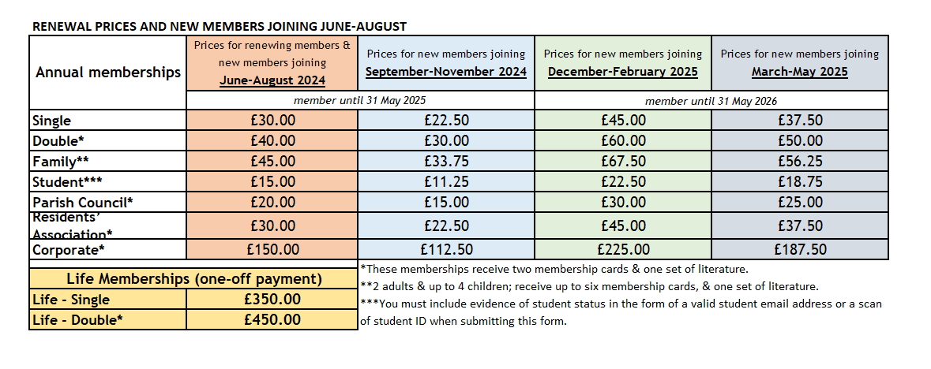
Please note pricing is inclusive of email communications. Occasional postal communications available for an additional £5 per year.
Data Use Policy

We use the information you share with us in this form to make sure you receive the service or information you have requested or bought, to keep in touch with you in the way that you have specified and to better understand our supporters so we can continue to improve our services. We do not share your data with any third parties for commercial or marketing purposes. For further information please see https://www.bath-preservation-trust.org.uk/privacy-policy/

***

How did you hear about us?
☐ Word of mouth
☐ Google
☐ Email newsletter
☐ Social media
☐ Magazine / other press
☐ Other (Please specify: ………………………………………………………..)

