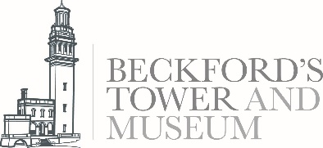
What is a Museum Volunteer?
Our Museum Volunteers have an important role helping people of all ages explore Beckford’s Tower and Museum and the collections.
We are looking for people with a friendly and flexible approach who will enjoy a varied and busy role, giving you a chance to share your enthusiasm for Beckford’s Tower with people of all ages.
Volunteers will receive an induction and training to enable you to undertake the responsibilities of the role. Through the new layered interpretation, the Tower and Beckford’s story will be identified and explained with authenticity, integrity and sensitivity. We will require all our volunteers to address the subjects of transatlantic slavery and sexuality with openness.
We are looking for people with experience of working with the public in a customer facing role with great customer service skills. Experience of working in museums would be useful but is not essential as full training will be given. The roles will start from March 2024 with some training sessions being held in February 2024.
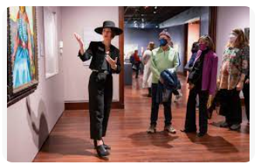
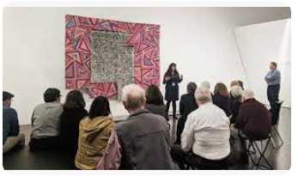

What’s in it for you?
- Becoming part of a team of sociable, friendly and enthusiastic people of mixed ages and experience
- Meeting people from all walks of life and making new friends
- Gaining valuable experience in the heritage sector
- Taking part in a programme of social events
- Opportunity to conduct new research for the interpretive scheme and to help create the content for the suite of tours and talks (only if you feel comfortable)
- Opportunity to be trained on giving ‘Lightning Talks’ ‘Lantern Tours’ and ‘Object Handling Sessions’ (only if you feel comfortable)
- Receive training, such as: Anti-racism and Diversity Training, Customer Service, and Collections Care
- Opportunity to participate in the Volunteer Development Programme
- Receive free entry into Bath Preservation Trust museums after 6 months and have access to the Tower library

What’s involved?
- Providing lightning talks to visitors
- Giving Lantern Tours to visitors
- Deliver object handling sessions
- Support specialist interest tours as required
- Providing information to visitors and answering enquires
- Occasionally answering enquires about burials and family history research at Lansdown Cemetery
- Having a flexible and positive attitude to learning new information and skills quickly
- Becoming familiar with and signing the BPT Safeguarding policy and being willing to have a Disclosure and Barring Services check if a particular level of volunteering involvement requires it
- Becoming familiar with and then following Bath Preservation Trust’s Health and Safety Policy at all times
- Giving any other appropriate assistance in relation to the role as may be reasonably requested
- Opportunity to be part of the ever-growing programming of events and activities at the museum

This role will suit people who are interested in the history of architecture and / or the life and work of William Beckford, as well as those who have an interest in decorative art and furniture.

Extra information
Your place | Beckford’s Tower and Museum
Time commitment | Minimum one shift per month and minimum 3 months commitment
Reporting to | Marie Brewer, Learning and Engagement Officer
Expenses | Out-of-pocket travel costs between home and volunteering place will be paid, and other reasonable expenses agreed in advance
How to apply Please send an email to our Learning and Engagement Officermbrewer@bptrust.org.uk or phone 01225 460705

About Bath Preservation Trust
Bath Preservation Trust was founded in 1934 as a small pressure group, with the object of protecting the city’s unique architectural heritage. Its first action was to fight plans to pull down parts of the picturesque Georgian city of Bath, England, to make way for a new road. The road was never built. Since this victory, the Trust has saved hundreds more listed buildings from demolition, and has successfully confronted many similar threats to the city. Today the Trust has approximately 1,400 subscribing members from the UK and overseas supporting its work.
The Trust exists “to preserve for the benefit of the public the historic character and amenities of the City of Bath and its surroundings”. In a City with such a wealth of heritage there are inevitably difficult challenges to be faced in reconciling the demands of a modern thriving City alongside the exceptional level of conservation care demanded in a World Heritage Site. The 21st Century has brought with it the added pressures of encroachment to the City’s green belt setting. The role and influence of the Trust is needed as much now as ever before.
The Trust is also a major provider in the tourist and domestic economy as it owns and runs museums and educational activities at No. 1 Royal Crescent, The Countess of Huntingdon’s Chapel, Beckford’s Tower and the Herschel Museum of Astronomy, all of which have been restored by the Trust and provide a valuable resource for the city’s residents and its visitors.
The Bath Preservation Trust is an independent charity, registered with the Charity Commission of England & Wales, and is a company limited by guarantee. It has a voluntary Chairman and board of Trustees. With prudent management the Trust is financially self-sufficient and independent of any controlling agency; a unique position for a heritage organization to hold within the UK.
Find out more: Contact us via the details available on our website or mbrewer@bptrust.org.uk 01225 460705
This is a voluntary role, so it isn't legally binding or a contract.

