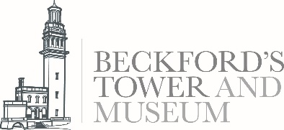

What is an Evaluation Volunteer?
Our Evaluation Volunteers have an important role helping gather data that will impact the life and sustainability of Beckford’s Tower and Museum.
We are looking for people with a friendly and flexible approach who will enjoy a varied and busy role.
Volunteers will receive an induction and training and to enable you to undertake the responsibilities of the role.
Through the new layered interpretation, the Tower and Beckford’s story will be identified and explained with authenticity, integrity and sensitivity. We will require all our volunteers to address the subjects of transatlantic slavery and sexuality with openness.
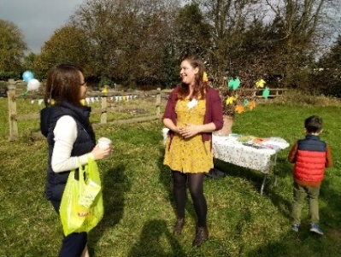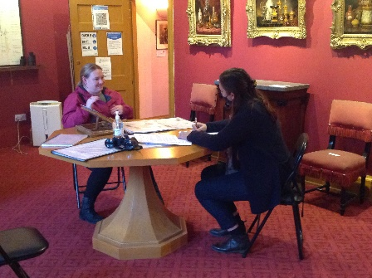
What’s in it for you?
- Becoming part of a friendly and dedicated team
- Meeting people from all walks of life and making new friends
- Gaining valuable experience in the heritage sector
- Taking part in a programme of social events
- Receive training, such as: interviewing skills, data collection and simple evaluation sills
- Opportunity to participate in the Volunteer Development Programme
- Receive free entry into Bath Preservation Trust museums after 6 months and have access to the Tower library

What’s involved?
- Interviewing visitors in the Tower and Museum
- Data collection
- Basic data analysis
- Providing information to visitors and answering enquires
- Having a flexible and positive attitude to learning new information and skills quickly
- Becoming familiar with and then following Bath Preservation Trust’s Health and Safety Policy at all times
- Giving any other appropriate assistance in relation to the role as may be reasonably requested
- Opportunity to be part of the ever-growing programming of events and activities at the museum

This role will suit people who are interested in evaluation work within the heritage sector and want to gain valuable skills.

Extra information
Your place | Beckford’s Tower and Museum
Time commitment | No regular commitment required, but we would hope that you would enjoy it and want to do more than one event. For most events we run a volunteer rota, with time slots of usually around 2 to 3 hours, so that you do not need to commit to a whole day, unless of course you want to!
Reporting to | Marie Brewer, Learning and Engagement Officer
Expenses | Out-of-pocket travel costs between home and volunteering place will be paid, and other reasonable expenses agreed in advance
How to apply Please send an email to our Learning and Engagement Officer mbrewer@bptrust.org.uk or phone 01225 460705

About Bath Preservation Trust
Bath Preservation Trust was founded in 1934 as a small pressure group, with the object of protecting the city’s unique architectural heritage. Its first action was to fight plans to pull down parts of the picturesque Georgian city of Bath, England, to make way for a new road. The road was never built. Since this victory, the Trust has saved hundreds more listed buildings from demolition, and has successfully confronted many similar threats to the city. Today the Trust has approximately 1,400 subscribing members from the UK and overseas supporting its work.
The Trust exists “to preserve for the benefit of the public the historic character and amenities of the City of Bath and its surroundings”. In a City with such a wealth of heritage there are inevitably difficult challenges to be faced in reconciling the demands of a modern thriving City alongside the exceptional level of conservation care demanded in a World Heritage Site. The 21st Century has brought with it the added pressures of encroachment to the City’s green belt setting. The role and influence of the Trust is needed as much now as ever before.
The Trust is also a major provider in the tourist and domestic economy as it owns and runs museums and educational activities at No. 1 Royal Crescent, The Countess of Huntingdon’s Chapel, Beckford’s Tower and the Herschel Museum of Astronomy, all of which have been restored by the Trust and provide a valuable resource for the city’s residents and its visitors.
The Bath Preservation Trust is an independent charity, registered with the Charity Commission of England & Wales, and is a company limited by guarantee. It has a voluntary Chairman and board of Trustees. With prudent management the Trust is financially self-sufficient and independent of any controlling agency; a unique position for a heritage organization to hold within the UK.

Find out more: Contact us via the details available on our website or mbrewer@bptrust.org.uk 01225 460705
This is a voluntary role, so it isn't legally binding or a contract.

