23/00257/FUL
Land Rear Of Dixon Gardens, Upper Lansdown Mews, Lansdown, Bath, Bath And North East Somerset
Erection of detached, split-level dwelling with car parking, access drive, associated infrastructure and landscaping, and including partial demolition of boundary wall to facilitate vehicular access.
Object
The proposed site of development is a narrow parcel of land to the north and west of the existing Dixon Gardens residential suburb, immediately to the rear of the Grade I Lansdown Crescent and situated within the Bath Conservation Area and World Heritage Site. The land comprises a series of stepped terraces to the north and enclosed within tall, retaining walls in coursed rubble stone. The walls and terrace are Grade II listed as part of the former nursery gardens of William Beckford, with design attributed to H E Goodridge, and historically formed part of the designed landscape known as Beckford’s Ride. The garden site is also attributed group value as part of the setting of the Grade I listed 20 Lansdown Crescent as a designed, Picturesque route between Beckford’s residence at 20 Lansdown Crescent and Beckford’s Tower in Lansdown (also Grade I listed). The assemblage also includes Beckford’s Gate, which is separately listed Grade II.
The remains of Beckford’s garden provide an open setting and context for this group of Grade II and Grade I heritage assets, which demonstrate their original function as part of a designed landscape garden associated with one of the city’s most famous residents and designers. The site of the proposal is an integral element of the wider designed landscape conceived and designed by Beckford, culminating in the now Grade I listed Beckford’s Tower.
The site is a relatively complete example of an early 19th century landscape garden of architectural and historic significance, and evidential value as an example of Georgian town planning built to Picturesque principles of the integration of town and countryside, and direct connection to Lansdown Crescent with its rural landscape setting. As such, it directly demonstrates the Outstanding Universal Value of the World Heritage Site through Georgian Town Planning and Landscape Setting.
It is critical to acknowledge the historic association of this site with William Beckford as a purpose-built Ride to Beckford’s Tower, a building which was funded by Beckford’s ownership of plantations and enslaved people in Jamaica. Today, Beckford’s Tower is owned and run by Beckford Tower Trust, part of BPT, and is currently undergoing a major project to repair and restore the Tower, improve its relationship and connections with its historic landscape setting, and create a new museum experience that will reveal more about Beckford’s life, including the wealth he gained from the transatlantic slave trade, his sexuality and isolation, as well as his creative life as a writer, composer and collector. This site, far from being attributed a lesser historic significance, should therefore be considered to contribute to the cumulative understanding of Beckford’s place within Bath and the wider landscape of Beckford’s Tower. Retention of this fragment of the Ride would therefore form part of the expanding public benefit offered through BPT’s current work to reinterpret Beckford’s story and engage with a wider, contemporary audience.

Principle of Development
BPT previously stated an in principle objection to any development on the site, in response to previously withdrawn application 14/04025/FUL, where the development of a dwelling would result in substantial harm to the interrelated garden setting of a group of Grade II heritage assets, and their group value as part of the lower section of a garden designed between 1822 -1844 by William Beckford (1760-1844) and the Bath architect Henry Edmund Goodridge (1797-1864). We concluded that the siting, position, design, massing and form of the proposed dwelling, in such close proximity to the listed structures, would be a visually intrusive structure that would result in substantial harm to the character and setting of the identified heritage assets.
We have reviewed this application and recognise the ambition to achieve subservience and efforts to mitigate harm, and that changes that have been made to the scheme to reduce the height and the overall length of development by pulling away from the eastern edge of the site and partially recessing the building below ground level. They do not however to not overcome our grounds for serious heritage concern and we maintain our in-principle position against any development on the site and the loss of the historic garden and setting.
The development as proposed would occupy a prominent position, elevated over the adjoining housing at Dixon Gardens and within close proximity of the southern retaining wall. Context elevations indicate that this would be clearly visible as part of the backdrop of Dixon Gardens and its legibility would be increased due to the removal of the existing tree coverage along the southern boundary. Whilst the Landscape Plan indicates the proposed use of a 1.8m trellis fence with evergreen climbers, this has been excluded from relevant elevations and sections. The resulting adverse impact is that of an increased build-up of the site and significant intrusion upon the grouped value and views of a historic landscape garden and its surviving historic structures and enclosure.
The Heritage Statement summarises that “The historic use is no longer immediately apparent to visitors (on private land). Generally the terraces are unkempt, with mature vegetation and are no longer used in the manner originally intended by Beckford”. Whilst the site is not currently publicly accessible, it should be emphasised that the contribution the setting makes to the significance of a heritage asset does not depend on there being public rights or an ability to access or experience that setting, where this could change in the future (Historic England, The Setting of Heritage Assets, 2011). Nonetheless, the open garden character of the site is publicly perceived as part of the broader landscape setting of Dixon Gardens and the backland street scene of Lansdown Crescent, in which Beckford’s Gate and the retaining wall are positively framed as key built features against a backdrop of established tree planting (albeit with the recent addition of the apartment block at Beckford Gate).
The proposed development, by virtue of its position and appearance, would therefore be clearly legible in existing short-range public and private views (see Appendix Two) as an elevated urban addition, which would neither preserve nor enhance the picturesque character, and would have an adverse impact on the group value, architectural interest and setting of multiple Grade II heritage assets and their contribution to the character and appearance of the conservation area, as well as harm to the green setting of the wider townscape which currently serves to visually break down its urban massing and grain.
The photomontages of the site, when compared with earlier photographs included as part of application 14/04025/FUL, have highlighted a notable decline in the condition of the site over the last eight years, including vegetation overgrowth and associated deterioration of stonework (see Appendix One). We agree with the statement made in the D&A Statement that “the current site is overgrown and would need a general maintenance programme to be put in place even without any of the proposed development taking place”. It is apparent that general maintenance works were being undertaken prior to 2014. We therefore question the inclusion of maintenance works, such as vegetation clearance and conservation-grade repairs to the boundary walls, within the public benefits identified within the Planning Statement, when it is clear that there has been a sharp decline in the condition of the site, correlating with the timeline of development interest for the land. Paragraph 196 of the NPPF sets out that “where there is evidence of deliberate neglect of, or damage to, a heritage asset [our emphasis], the deteriorated state of the heritage asset should not be taken into account in any decision.” The condition of the site as existing, and as may arise from a continued lack of maintenance, should therefore be attributed no weight as part of the planning balance in favour of the scheme.
Where para 201 of the NPPF specifies that identified substantial harm to a designated heritage asset should be outweighed by demonstrated “substantial public benefits”, we do not consider that the proposed benefits, which are largely private, would demonstrably outweigh identified harm, nor would development “preserve those elements of the setting that make a positive contribution to the asset (or which better reveal its significance)”. Benefits such as proposals for public access on a set number of days per year or on-site interpretation would need to be secured via an appropriate mechanism to ensure this would be delivered. There is also no conclusive evidence that residential development is necessary to secure the optimum viable use of the site, or that other, more “reasonable uses of the site” with reduced heritage harm, could not be achieved.
We therefore maintain that development would result in cumulative, substantial harm to multiple heritage assets, including:
- The garden setting of the Grade II retaining walls and terraces of the former nursery gardens and the Grade II Beckford’s Gate, the setting of which is integral to the sustained evidential and architectural interest of a historic designed landscape.
- The interrelated setting of the Grade I 20 Lansdown Crescent, as identified by Historic England as significant in interpreting the garden’s connection with the former residence of William Beckford.
- The character and appearance of the Bath Conservation Area.
- The contribution of the site to the Georgian Town Planning OUV of the World Heritage Site.

Identified Harm to Retaining/Boundary Walls
BPT maintains further concerns regarding proposals for the new dwelling to be set below ground level, and the potential adverse impact on the structural integrity of the southern retaining wall between the site and the gardens of 4 &5 Dixon Gardens. The Structural Engineer’s Investigations Report identifies that the wall as existing is in good condition (despite some areas of missing stone and mortar) with no indication of failure under the existing lateral loading. The report summarised that “any works in the proposed development should be detailed to ensure no additional loads are applied to the back of the wall by taking the formation level of new foundations to such as level as to not surcharge the existing wall.” As yet, there is currently very limited information as to the structural construction or foundations of the proposed dwelling, despite the fact that built development would be located within very close proximity to the retaining wall due to the tight constraints of the site, and ¾ of the existing ground level would be excavated to accommodate ‘Level 00’ of the dwelling (see section 1.1, drawing 242.3.130). It is unclear as to what measures would be undertaken to minimise further structural loading on the retaining wall and the resulting long-term impact on the integrity of historic fabric. It is therefore difficult to assess the degree of heritage harm, as well as the feasibility of the proposed build.
It is proposed to remove a section of stone boundary wall to the southern end of the site to create a route for vehicle access onto the site – this was previously retrospectively proposed in 2015 (see 15/04695/FUL) following the unauthorised demolition of this section of wall, which was subsequently reinstated in 2017 under an enforcement notice. Whilst this section of wall was previously unlisted, the Grade II listing was updated in 2018 to specifically incorporate this section of wall, post-reconstruction, as part of “a relatively complete walled and terraced garden dating from about 1825-1830” (Historic England).
We therefore maintain our previous objection on grounds of harm to the architectural and historic interest of the Grade II structures on the site and their grouped value as part of an important heritage landscape. The Heritage Statement concludes that “the opening itself has been subject to change and so the sensitivity is less than if it were pristine”; however, this does not account for the wall’s grouped significance as part of an enclosed landscape, deemed to be of enough merit to be formally included within the Grade II listing despite having been demolished and reconstructed.
The application does not provide a sufficient level of detail relating to the degree of demolition works across the site; the site plan as provided in Appendix 4 of the Transport Statement indicates that a 1.04m2 section of eastern retaining wall (overlooking 3 Dixon Gardens) would be removed to accommodate the proposed driveway alignment and embankment, but this further loss of historic fabric is not elaborated on within the Heritage Statement or as part of the planning balance.
The extent of the southern boundary wall, whilst having already been compromised by the addition of an opening as part of the 1950s development of Dixon Gardens, remains an attractive feature of the local street scene along Upper Lansdown Mews, indicative of the area’s backland character. Further removal of the southern wall would not preserve or enhance the character or appearance of the conservation area, or the indicative setting of Lansdown Crescent. Where there would be a cumulatively substantial level of harm to a number of heritage assets, the identified benefits for vehicle access to the site would be private rather than public and would fail to outweigh the identified harm.
Demolition would therefore result in harm to the special interest of a Grade II structure and the interrelated setting of multiple heritage assets, contrary to the Planning (Listed Building and Conservation Areas) Act 1990, Section 16 of the NPPF, and Policies B1, BD1, B4, D1, D2, D7, and HE1 of the Core Strategy and Placemaking Plan.

Vehicle Access
The site is ill-suited to traffic access, necessitating the hard surfacing of the entirety of the west terrace, incorporated into the existing listing of the retaining walls and terraces of the former nursery garden in 2018, to facilitate access to car lift parking to the front of the proposed dwelling. The route would vary in width between 2.5m – 3.5m which would only have capacity for single lane vehicle access, with over-reliance on two turning points to the top and middle of the site to address conflict between vehicles meeting one another. In accordance with Policy D4, “car parking and highways design should not dominate the design of the development or the public realm.”
We highlight further concerns that the laying of hard surfacing would result in the loss of designed landscape originating from 1822-1825; photographs of the site from 2014 indicate the presence of a stone-edged pathway (see Appendix Three) which may be indicative of a historic marked route or pathway. The Heritage Statement makes reference to “a nominal path that was presumably left over during the construction of Dixon Gardens in the 20th century, to provide access to the land at the north”, and does not sufficiently consider the possible heritage value of this feature in association with the original use of the site.
As proposed, the development would be overly dependent on an excessive provision of hard landscaping to facilitate vehicle-to-door access, demonstrating that the site’s narrow constraints and tight layout could not successfully accommodate development.
This extent of hard surfacing would therefore be of additional detriment to the historic garden character and appearance of the site and the setting of the Grade II nursery (and would exacerbate the total biodiversity net loss experienced across the site) contrary to Policies D1, D2, D3, D4 of the Core Strategy and Placemaking Plan.

Biodiversity Net Loss
The D&A Statement indicates that it is considered development “does not contravene the local planning policies and will seek to deliver a net gain in biodiversity in line NPPF and local policy [our emphasis].” However, the Biodiversity Net Gain Assessment as submitted indicates that the development would result in a total net loss of -48.10%, despite cited mitigatory efforts such as retention/provision of fruit trees, implementation of a green roof, use of a more diverse grass seed mix, and “enhancement measures” for bats and nesting birds. This would require off-site provision of habitat delivery, although any details pertaining to site selection and delivery has not been provided.
This net loss further highlights the totality of harm to the significance of this garden plot; the extent of hard landscaping and urban build-out would be of detriment to the site’s shared ecological and heritage significance, contrary to the Environment Act 2021 and Policy NE3a of the Core Strategy and Local Plan (Partial Update).

Conclusion
For the reasons stated and justified above, the proposed development would result in substantial harm to the grouped setting and value of multiple Grade II and Grade I heritage assets, and would have an adverse impact on the character and appearance of the conservation area and the OUV of the World Heritage Site. The application would be contrary to the Planning (Listed Building and Conservation Areas) Act 1990, Section 16 of the NPPF, the Environment Act 2021, and Policies B1, B4 CP6, D1, D2, D3, D4, D7, HE1, and NE3a of the Core Strategy and Placemaking Plan, and should be refused.

Appendices
Appendix One

Image (left): Photograph of bottom section of the west terrace, proposed for use as driveway access to proposed dwelling, submitted in 2014 D&A Statement 14/04025/FUL.
Image (right): Comparative photograph of upper section of the west terrace, proposed for use as driveway access to proposed dwelling, submitted in 2023 Heritage Statement 23/00257/FUL.

Image (left): Photograph of the north terrace, proposed for the development of a single detached dwelling, submitted in 2014 D&A Statement 14/04025/FUL.
Image (right): Comparative photograph of the north terrace, proposed for the development of a single detached dwelling, submitted in 2023 Heritage Statement 23/00257/FUL.

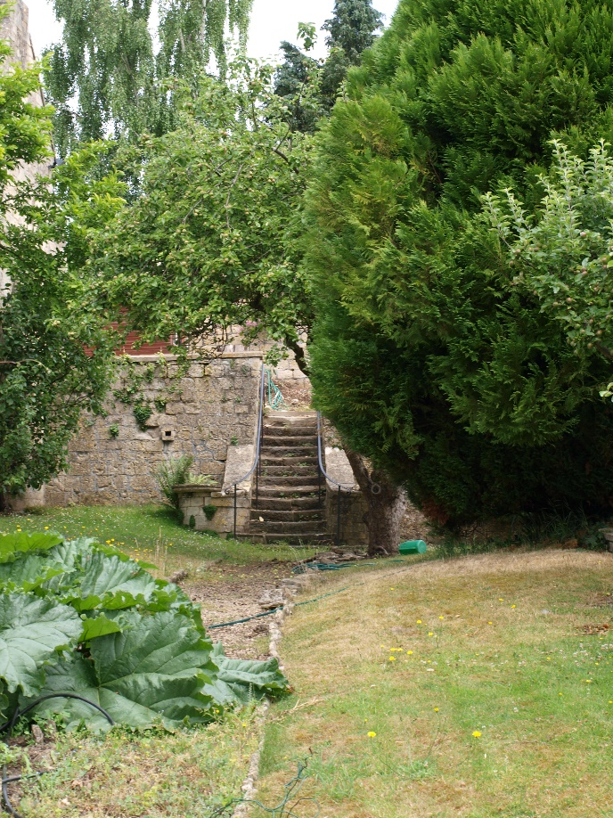

Image (left): Photograph of steps to the upper northern terrace, including stone coping edge to north-south defined pathway, taken by BPT on 2007 site visit.
Image (right): Photograph of steps to the upper northern terrace, submitted in 2023 Heritage Statement 23/00257/FUL.

Appendix Two

Image (above): Proposed visual of the south-facing elevation of the dwelling in relation to the southern retaining wall and the garden setting of Dixon Gardens, submitted in D&A Statement 23/00257/FUL.
Image (below): Proposed south context elevation of the dwelling in relation to Dixon Gardens, submitted Proposed Context Elevations 4 23/00257/FUL.
Appendix Three

Image (left): Photograph of the west terrace (looking south) including a stone-edged pathway running towards the north terrace, submitted in 2014 D&A Statement 14/04025/FUL.
Image (right): Photograph of the north terrace (looking east) including a stone-edged pathway running from the west terrace, submitted in 2014 D&A Statement 14/04025/FUL.

Image (left): Photograph of the north terrace (looking west) showing the intersection of the stone-edged pathway with the west terrace, submitted in 2014 D&A Statement 14/04025/FUL.

