Midford Castle, Access Road To Midford Castle, Midford, Bath, Bath And North East Somerset, BA2 7BU
Appeal APP/F0114/C/22/3307537
Enforcement Notice 21/00420/UNDEV
BPT Statement - Against

Midford Castle is a Grade I 18th century Gothick-style country house situated within a rural, wooded portion of Bath’s Green Belt, the Cotswolds AONB, and the indicative and landscape setting of the City of Bath World Heritage Site. To the north of Midford Castle is a cluster of ancillary Grade II* 19th century outhouses, including the Stables and Old Chapel, which positively contribute to the aesthetic and evidential understanding of Midford Castle’s function in the late Georgian period whilst enhancing the setting of a Grade I heritage asset.
A key aspect of Midford Castle’s aesthetic, architectural, and historic significance is derived from its position in the rural landscape, and the visual relationship shared between the Castle’s use of Gothick architectural traditions and its picturesque context. The Castle stands on an elevated platform, and the sloping parkland and scrub falling away contributes to its colossal prominence in the landscape.
The proposed appeal focuses on three areas of unauthorised works across the site:
- The construction of a two storey, partially subterranean agricultural building to the west of the Grade II* stables and old chapel, in breach of planning permission 19/03415/FUL.
- The unauthorised creation of a hardstanding area to the north-west of the site.
- The unauthorised creation of an access track between the new area of hardstanding and Midford Road.
The main focus of BPT’s response will be the breach of planning permission pertaining to original application 19/03415/FUL, with reference to our original objection responses as well as the planning reasons given for the selection of the final permitted design as part of a series of design revisions.

Breach of Planning Permission
The original proposed elevations, submitted 30/07/2019, show plans for a rectilinear single storey structure which appears to be two storeys in proportion. The structure would be partially sunk into the slope, with the upper half of the building finished in “ventilated larch cladding” (see Appendix 1).
In response to these proposals, the conservation officer summarised that development “would have a detrimental impact on the setting of significant heritage assets, including Midford Castle (Grade I) and The Stables, the Old Chapel and Remains of the Old Chapel, Walls Enclosing Stableyard, Coach House and Greenhouse (Grade II*) and the historic gardens and parkland” (see response dated 09/09/2019). It was requested that a “a less sensitive and more discreet location” was identified for the proposed agricultural building.
Subsequent revised drawings were submitted as of 07/11/2019. These included a new L-shaped floor plan to transfer building mass away from the eastern elevation and push the building back from the Grade II* coach-house opposite. Furthermore, the proposed elevations indicate a reduced roof height more in-keeping with the building’s single storey function which would largely sit below ground level (see Appendix 2).
Later revisions (see proposed elevations from 03/02/2020 onwards) included the proposed planting of a wildflower meadow across the roof of the proposed barn, and the backfilling of the area around the proposed barn to create a sloped embankment around the western side of the building (see Appendix 3). These works were intended to mitigate the visual impact of the barn by integrating it as far as possible within its landscape context. The conservation officer considered that this would “on balance […] largely overcome[s] the issue of visual harm to the setting of heritage assets” in their response dated 05/03/2020.
Therefore, a key consideration of the proposed design in relation to the granting of planning permission is the proposed height, massing, and recessed position of the building into the slope, in relation to its setting within the group of high significance listed buildings. In the Delegated Report (04/06/2021), the following statement indicates that design amendments, including associated landscaping works, have been considered to appropriately mitigate the visual impact of the building on its surroundings:
“The proposed building is to be part-subterranean and will be approximately the height of an existing soil embankment located on its south side. The building will also be enveloped by an existing sloping soil embankment located on its west side and will incorporate a green roof comprised of wildflower and grasses. Consequently, spatially, there will be minimal additional volume as a result of the development proposals [our emphasis]. The green roof has been designed so as to extend seamlessly from the surrounding soil embankments. Soil will be used to backfill any vacant volume around the building and to soften and sculpture the surrounding soil embankment and green roof ready for planting as native wildflower meadow. This approach has been employed in order to reduce the visual impact of the building from within the application site [our emphasis].”
In contrast, the two-storey agricultural building as built on-site (see Appendix 4) is not only clearly in breach of the permitted design and form of the proposed building, but fails to reflect or respond to the sensitive nature of the site and the relationship between the Grade I castle and its intentional, rural landscape setting. In scale and form, the as-built building is more comparable to the original 30/07/2019 drawings (see Appendix 1) in which the proposed flat roofline clearly protrudes above ground level and would be distinctly read as a separate building on the site. In both instances, only the perceived ‘ground floor’ level would be set into the slope, with the slope cutting down to reveal the front portion. The intersection of the building with the sloping ground level and associated trackway appears to match in both the 30/07/2019 superseded proposed east elevation, and the building as built (see Appendix 4).
It is therefore clear that the building as constructed bears strong similarities with earlier superseded plans for the site, albeit utilising the latterly-proposed L-shaped floor plan and introducing a two-storey element which was never proposed under application 19/03415/FUL at any stage. Development is consequently clearly in breach of the extant planning permission.
We further maintain that concerns raised by both Bath Preservation Trust and the conservation officer in response to the 30/07/2019 plans therefore apply to the building as built due to the similarity in scale, form, and massing:
In response to the 30/07/2019 drawings, the conservation officer summarised that “the scale of the proposed agricultural building and the excavation required to accommodate it is not regarded as being successful” the identified aims of being “modest and subservient” and enhancing the setting of a significant grouping of Grade I and Grade II* heritage assets. The case officer subsequently concluded that the scale of the building as originally proposed “was too large and that the building would therefore appear overly dominant and discordant in association with the ancillary buildings”, would “disrupt the existing hierarchy and historic layout of the site” and ultimately result in “significant harm” to the setting of multiple listed buildings (see Delegated Report, p. 10).
The main focus of proposed works was to relocate the boiler and solid fuel store from the vaults of Midford Castle; based on the permitted drawings, this use continues to be proposed (see proposed floor plans 22/04/2020, as permitted). As originally assessed by the conservation officer, it was considered that this use would only “require a building of only modest scale”. The apparent two storey height of development as built on the site therefore remains unjustified on viability grounds, and may instead be indicative of a planned variation of use. Please note that Condition 3 attached to the planning permission states that “the building hereby approved shall be used only for the purposes of housing a biomass boiler and for no other purpose unless otherwise agreed in writing by the Local Planning Authority.”
Development of this height and scale, comparable with the as-built structure on the site, is therefore considered to be of visual detriment on the setting of a group of significant heritage assets. The scale of development on site is therefore considered to be excessive and of resulting detriment to the landscape setting and associated significance of an important group of listed buildings, in accordance with BPT’s previous objection response (see Appendix 5).

Unauthorised Landscape Works
Previously unauthorised landscaping works had taken place on the site, including engineering works to excavate the proposed site of development and the relocation of the spoil on the south side of Midford Castle to the detriment of its landscaped setting. BPT originally highlighted that these retrospective levelling works had compromised the Castle’s elevated presence within its picturesque, rural location, contrary to its historic and aesthetic interest.
The applicant confirmed that as part of proposals “it has been agreed to use part of the excavation material to back fill with the remaining soil to be removed off site. The plinth around the south west side of the Castle will then be restored to the previous levels (prior to the 2019 operations). The mounding will then be topsoiled and planted with a wildflower seed mix.” It is as yet unclear as to whether these remedial works have commenced.
We are therefore highly concerned by reports of further, unauthorised landscape works including the creation of a new hardstanding area from a mix of old spoil and new spoil resulting from the creation of a new trackway. The site remains highly visible in long-range landscape views across the valley towards Combe Down and Monkton Combe, as well as in mid-range views to the east from Tucking Mill and the Bath Two Tunnels Circuit, and as such remains a landmark focus within a landscape that is predominantly undeveloped and rural in character and appearance. We continue to express concerns with the continued ‘build up’ of the Castle’s agrarian setting and the resulting cumulative harm to the landscape setting of a heritage asset of exceptional interest, and the wider character and special qualities of the Cotswolds AONB and the landscape setting of the World Heritage Site.
These landscaping works (see ‘B’ and ‘C’ in the Enforcement Notice) would require accompanying planning permission and as such remain unauthorised and subject to enforcement action.

Conclusion
The development as outlined in the accompanying Enforcement Notice remains in breach of the extant planning permission attached to the site, contrary to the Planning (Listed Buildings & Conservation Areas) Act 1990 and the Town and Country Planning Act 1990.
Development would result in a totality of harm to the setting of multiple high-significance heritage assets, including the Grade I Midford Castle and its Grade II* outbuildings, without sufficient justification of the harm being outweighed by demonstrated public benefit, contrary to Section 16 of the NPPF and Policies CP6, D1, D2, D3, and HE1 of the Core Strategy and Placemaking Plan.
Development would fail to sustain or enhance the special qualities of the Cotswolds AONB and the setting of the World Heritage Site, contrary to Section 15 of the NPPF and Policies B4, HE1, NE2, and NE2A of the Core Strategy and Placemaking Plan.
We therefore recommend that this appeal is dismissed.

Appendices

Appendix 1
Superseded Proposed East Elevation (30/07/2019)

Appendix 2
Superseded Site Section C through centre of Barn & East Elevation from Courtyard (22/11/2019)
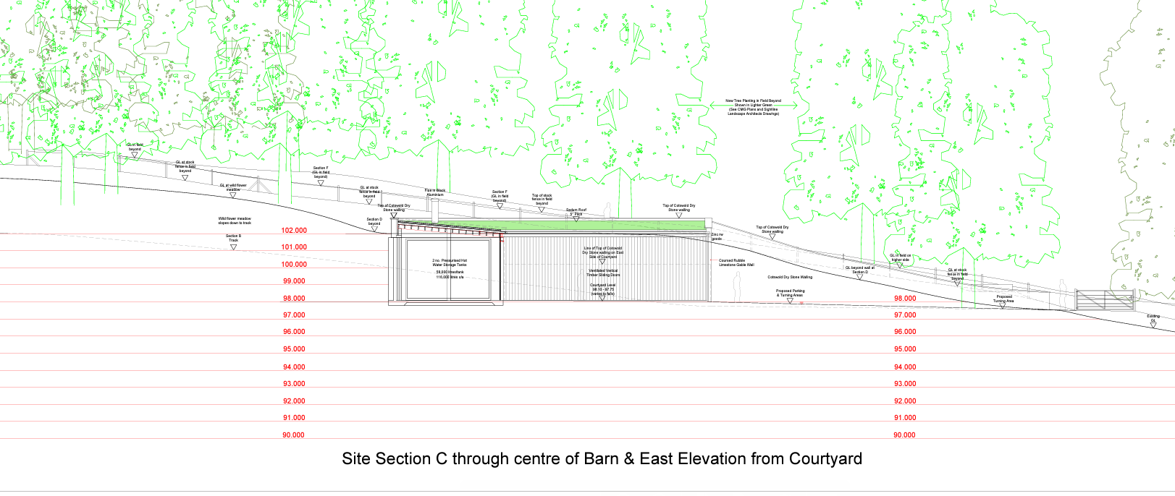

Appendix 3
Superseded Site Section B through Access Track and East Elevation of Barn
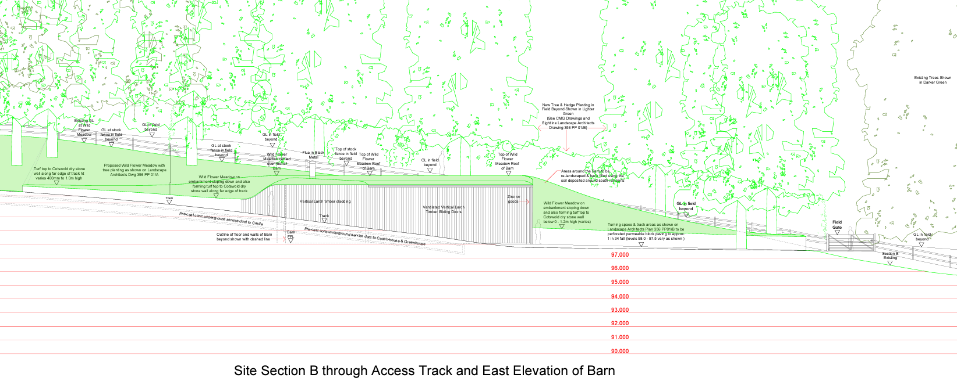

Appendix 4
Photo of the Building as Built (Enforcement Notice 26/08/2022)
Note BPT’s addition of a red dotted line to the left of the image indicating the ground level of the trackway in relation to the building – this appears to match the ground level as proposed in the 30/07/2019 west elevation.

Appendix 5
BPT Objection Response, Submitted 23/09/2019

19/03415/FUL
Midford Castle Erection of agricultural building and associated landscaping and land modelling works (part retrospective).
OBJECT
Midford Castle lies within the Green Belt, the Cotswolds Area of Outstanding Natural Beauty, the indicative setting of the City of Bath World Heritage Site, and the landscape setting of Bath.
Midford Castle is Grade I listed and the Stables and Old Chapel immediately to the sites east are Grade II* listed.
Given that Midford Castle is a Grade I listed building of the highest significant we would urge the LPA to encourage the conservation and care of this building through a conservation management plan. This should be a requirement of any further development on the site necessitating planning consent, and a Condition of any permission granted.
BPT has an in principal objection to the development because it has already had a major adverse impact on the heritage significance and setting of the listed building, and the local landscape character and this adverse impact would be further exacerbated by the construction of the proposed agricultural building.
Undertaking works to listed building without first obtaining the relevant permissions is unlawful. We take the disregard of planning regulations which exist to protect the unique value of heritage assets very seriously. We do not consider that retrospective permission should be granted and the LPA should take the necessary steps to remedy this breach and reverse the harm caused.
The fact that the work has been undertaken without permission has resulted in substantial harm to the special interest and significance of Midford Castle. The LPA should send out a strong message that this unlawful approach to heritage buildings is a contravention that can lead to prosecution, rather than allowing or indeed encouraging the applicant to continue to undertake work without due diligence.
We strongly object to this application and recommend that it is refused for the following reasons.
Landscaping work
The positioning of the Castle in the landscape and its relationship with it contributes to the significance of the heritage asset.
The Castle stands on an elevated platform, and the sloping parkland and scrub falling away contributes to its colossal prominence in the landscape. The levelling and extension of the platform surrounding the Castle, and the creation of a domestic garden has compromised the appearance and elevated presence of the Castle in its romantic landscape setting, and contradicts its aesthetic interest.
The landscaping work undertaken therefore has a major adverse aesthetic impact on Midford Castle in its landscape setting.
Agricultural building
Woodlands and trees in close proximity to the Caste have historically contributed to its romantic setting and make a positive contribution to the aesthetic significance of the listed building.
Historic maps evidence the existence of trees that have been removed in the location of the proposed building. The siting, size and appearance of the agricultural building and associated loss of woodland has the potential to detract from landscape character and harm the setting of the Castle.
The presence of a modern agricultural barn would not sit comfortably with the style and scale of other domestic stone buildings that form a group within this estate.
Furthermore, the applicant has not demonstrated that the building is needed for agricultural reasons. The Castle and estate do not appear to be a working farm. There is insufficient justification for the proposed agricultural building, which fails to bring any public benefit to outweigh harm.
The siting, appearance and permanent loss of woodland in its location causes substantial harm to the setting, group value, and romantic landscape significance of Midford Castle.
In conclusion
The harm caused would be substantial in its accumulated impact on this heritage asset. The NPPF paragraph requires that great weight is given to harm caused to heritage assets.
We do not consider that any planting or screening would mitigate against the harm already caused. This application is therefore contrary to the NPPF, the requirements of the Planning (Listed Buildings and Conservation Areas) Act 1990, and Placemaking Plan, D2 (Local character and distinctiveness), HE1 (Historic Environment), NE2 (Conserving and enhancing the landscape and landscape character), and B4 (World Heritage) and should be refused.
BATH PRESERVATION TRUST
September 2019

