MEMBERSHIP APPLICATION/RENEWAL FORM (Including Gift Aid Declaration)

Please fill in the form below and email it to membership@bptrust.org.uk or post it to No.1 Royal Crescent, Bath, BA1 2LR

Name
Name of Joint Member if any
Address
Postcode
Telephone Number
Email address

Membership type:
Please see pricing structure overleaf
Single | £
Double | £ | 2 members at same address
Family | £ | 2 adults & up to 4 children under 16 years
Student | £
Parish Council | £ | 2 representatives
Residents Association | £ | 2 representatives
Corporate | £ | 2 representatives
Life Membership - Single | £
Life Membership - Double | £ | 2 members at same address

I enclose an additional donation of £______ | Total payment: £______

Payment method:
Please tick the box to tell us how you wish to pay
☐ Direct debit
We will send you a link by email to securely set up your direct debit.

☐ Cheque
Payable to Bath Preservation Trust. Please post this form to us and enclose your cheque.

☐ BACS or standing order
A/c name: Bath Preservation Trust. Sort Code: 40-52-40, A/c No.: 00016997, quoting your first and surname as the reference. Please note that in case of membership rates increasing, you will need to arrange for the standing order amount to be altered with your bank.
☐ Credit or debit card
Please fill the section below. Your card details will be deleted once payment has been processed. Alternatively, leave the form blank and we will get in touch to arrange payment over the phone. Please note that we cannot accept American Express.
Card Number (only if paying by credit or debit card):
/
/
Valid from: MM / YY Expiry: MM / YY

3-digit security number on the reverse of the card:

Signature(s) (type your name(s) if you send this form by email) Date _________

Gift Aid Declaration (UK taxpayers only)
☐ I am a UK Taxpayer and I understand that if I pay less Income Tax and/or Capital Gains Tax in the current tax year than the amount of Gift Aid claimed on all my donations, it is my responsibility to pay any difference.
☐ I want to Gift Aid my donation of £______________ and any donations I make in the future or have made in the past 4 years to Bath Preservation Trust. (Please note you can end this at any time by getting in touch with us.)

Signature __________________________________________ (type your name(s) if you send this form by email)

Pricing Structure

To save on costs we are endeavouring to get all our members on the same Renewal timeline – 1st June. Hence the pro-rata pricing structure below with quarterly rebates for those joining during the course of the year, e.g. if you join after the 30th Nov you pay up until June 2024 (price locked for another year!).

If you prefer to pay the full price and choose to treat the extra as a donation, we would be most grateful!

Please note that all membership fees listed below are for postal memberships. If you opt for a digital membership, you will receive a £5 discount on your membership.

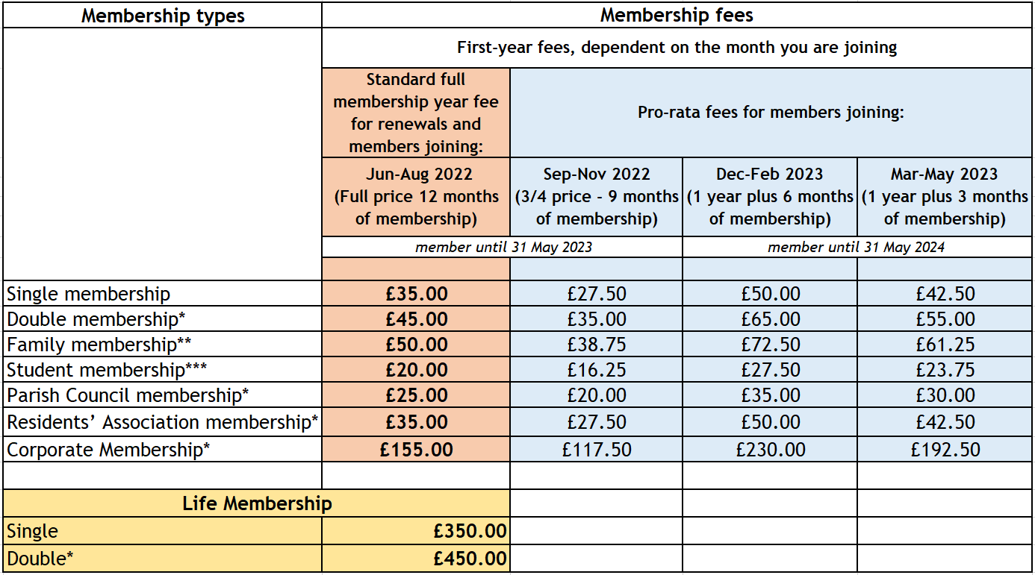

*These memberships receive two membership cards and one set of literature.
**Family memberships receive up to six membership cards, depending on how many individuals are in the family, and one set of literature.
***You must include evidence of student status in the form of a valid student email address or a scan of student ID when submitting this form.

Data Use Policy

We use the information you share with us in this form to make sure you receive the service or information you have requested or bought, to keep in touch with you in the way that you have specified and to better understand our supporters so we can continue to improve our services. We do not share your data with any third parties for commercial or marketing purposes. For further information please see https://www.bath-preservation-trust.org.uk/privacy-policy/

