Appeal Reference: APP/F0114/W/21/3285251
Application 20/04546/OUT
St Martin's Hospital, Clara Cross Lane, Odd Down, Bath, Bath And North East Somerset, BA2 5RP

The Bath Preservation Trust (BPT) calls for this appeal to be dismissed on the following grounds.
We maintain that this development constitutes OVERDEVELOPMENT of the site and UNJUSTIFIED harm to the setting and significance of a listed building, and harm to the grouped character and significance of the wider Grade II complex of the Bath Union Workhouse.
In this statement, BPT will argue that this scheme is not compliant with local and national policy, and Reason 1 for refusal as stated by B&NES Council should be maintained as follows:
“1. The development due to its inappropriate scale, design and siting is considered to have a detrimental impact upon the setting of the Grade II listed Chapel and the wider St Martins site. In the language of the Framework, the harm is considered to amount to less than substantial harm. However, there are no public benefits which outweigh the level of harm identified. The development is therefore considered to be contrary to Placemaking Plan policies HE1, D1, and D2 and Core Strategy Policy CP6.”
BPT will not be considering Reason 2 as part of our statement. However, we will consider the significance of sustained green space where this overlaps with heritage concerns.
As part of our assessment of the negative qualities of the development, we will need to consider the relative impact of development on the special qualities of multiple heritage assets. This will include the following:
- Grade II St Martin’s Chapel and setting, including the historic Burial Ground.
- Setting of Grade II St Martin’s Hospital, formerly the Bath Union Workhouse, now ‘the Hexagon’.
- The Bath World Heritage Site.
Site Overview
The proposed site of development is located in close proximity to the Grade II listed St Martin’s Chapel, opened in 1846 as part of the former early 19th century Bath Union Workhouse complex, now residentially occupied as ‘the Hexagon’ and Grade II listed. The chapel remains a prominent and distinctive feature in wider streetscape views along Midford Road, and strongly characterises the north-eastern boundary of the former workhouse site alongside the formal three storey façade of St Martin’s Hospital.
The setting of the chapel is a well-treed green space, and it is indicated that the proposed site of development would partially encompass the historic boundary of the burial ground attached to the east side of the chapel where over 1,100 residents of the workhouse were buried.
As well as being of historic and evidential significance, the site has attributed social significance as a key, publicly accessible green space in a built-up residential area. In the Committee Report of application 04/03578/FUL (“Conversion of original hospital building to 58 no. apartments including 33 for key workers; conversion of former laundry building to 8 no. apartments; conversion of old bakery building to 3 houses”), it is stated that:
“This planning application generates the need for at least one Locally Equipped Area for Play (LEAP) to be provided in the proposed play area on the south side of St Martins Hospital site, adjoining Frome Road. The open space shown adjoining the existing chapel should also be provided (our emphasis). If planning permission is to be granted for the proposed development then the provision of the open space and the play area and equipment must be assured by the applicant entering into a legal agreement with the Council.”
The subsequent Section 106 agreement secured the adoption of Public Open Space. It is acknowledged that the area of the chapel site proposed for development is outside of the Chapel Public Open Space defined boundary, but functionally is an extension of this open, accessible green space and consequently shares in this social value.
The site is located within the Bath World Heritage Site. It does not constitute one of the Outstanding Universal Values of Bath’s Roman or Georgian significance, but remains a notable contributor as largely intact Victorian workhouse to the 19th century social significance and working class history of Bath’s as a living city.
Adverse Impact to Heritage Assets
The appellant’s Statement of Case emphasises that “the proposal will result in the removal of a building which harms the setting of the listed building and detracts from the area… Conversely, the proposals will provide […] a well-conceived and designed new building constructed from high quality materials appropriate for the site and its setting”.
BPT continues to acknowledge that the existing structures on the site are of a neutral value to the area at best, and we do not object to their removal or replacement.
HOWEVER, this statement does not account for the relative benefits of the existing structures as low mass single storey buildings well-screened with established tree planting from the setting of the Grade II St Martin’s Chapel. Consequently, it can be argued that their visual impact on the setting of the Grade II listed chapel and workhouse is suitably mitigated, and their low height and scale remain subservient to the established massing of the wider complex. The resulting harm from the increased build-up of this site and encroachment on the setting and prominence of the chapel has not therefore been appropriately realised or justified through the proposed benefits of the removal of the existing structures.
The case officer has already dismissed the existing structures on the site as an inappropriate precedent for development of an increased scale as follows (see refused application 19/00021/FUL, Delegated Report): “Whilst there is already a structure in this location which does not contribute to the setting, by adding a larger building of this scale, this impact upon the setting is compounded and not improved (our emphasis).”
The proposed elevations as part of application 20/04546/OUT (whilst reduced by a storey to 2 storeys total) continue to bear a strong resemblance to the proposed elevations in refused application 19/00021/FUL, with the continued use of a flat-roofed form and an aluminium panel treatment to the upper floor elevations. Application 19/00021/FUL was similarly refused on grounds of “its inappropriate scale, design and siting [which] is considered to have a detrimental impact upon the setting of the Grade II listed Chapel and the wider St Martins site”, and is not sufficiently outweighed by public benefit.
We therefore maintain that the similarities in design, scale, and massing continue to have an adverse impact on the setting and significance of the Grade II chapel.
The design as proposed is architecturally and aesthetically isolated from its historic setting and local townscape. The use of the stepped back flat roof form is not found locally and is not appropriate. It is only used to increase the quantum of development and is of a visual appearance that is at odds with and alien to the mixed local domestic scale townscape. The use of aluminium metal cladding further contributes to the incongruous appearance of the proposed building by introducing an unreferenced, industrial element to the site.
The use of render across prominent or principle elevations is incoherent with the material vernacular of the Hexagon site, defined as Bath stone ashlar and gabled roofing which is materially reflected in the chapel’s external treatment. The extensive use of render would have a sharp and bright appearance against the site’s primarily natural Bath stone context. This would not acceptably “harmonise with the local character and palette” as claimed by the appellant.
Furthermore, the appellant asserts that “the level of intervisibility between the appeal site and the Chapel is relatively low.” Whilst the established trees along Midford Road do ‘interrupt’ views of the site, there remains a clear inter-visibility between the chapel and its setting, which is best highlighted during the winter months (see Appendix 1). Within these views, the visual dominance of the chapel is strengthened and enhanced by its verdant setting. The close proximity development of a two storey building of large massing with a flat, blocky profile, combined with extensive hard landscaping and the removal of existing green infrastructure, would challenge the chapel’s standalone character and detract from the chapel’s prominence. Sat up against the pavement edge along Clara Cross Lane, the development would comprise a jarring, over-dominant insertion into the streetscape which would further close off the attractive, open characteristics of the site.
We do not agree with the appellant’s assertion that the development “at the very least will preserve [the setting of the heritage asset] by doing no more harm than the existing building (our emphasis).”
The development would constitute a permanent built intrusion of increased scale and massing into the setting of a listed building, and the transient tree cover in the area is not considered to appropriately mitigate perceived harm. The development would therefore result in further compounded harm to the setting of a listed building without demonstrated public benefit.
We maintain that the loss of green space would be detrimental to the setting of the listed buildings. Whilst grasscrete is now proposed for the north-east parking area, this would occupy a significant proportion of the previously open green space and would read as a car park for the majority of the day when in use, encroaching on the eastern elevation of the chapel. This would continue to constitute a stark, visual intervention in the streetscape of Clara Cross Lane, and would continue to have a visual detriment on the verdant context of St Martin’s Chapel through the removal of green screening and setting. This aspect of the scheme has continually been excluded from contextual views of the site.
The development’s intersection with the historic burial ground setting of the chapel, particularly to the north-east where the proposed car parking would be situated, has been poorly considered and inadequately explored or assessed in relation to the burial ground’s cumulative significance to the understanding and experience of the chapel, and the wider coherent significance of the Grade II workhouse complex.
Part of the significance of the Grade II St Martin’s Hospital site is its historic, aesthetic, and architectural relationship between the hospital building and St Martin’s Chapel and the resulting visual uniformity of the site in architectural treatment. The green setting of the chapel, whilst likely not “deliberately placed ‘within a wider landscape’”, is indicative of the site’s burial ground function in close association with the chapel, and the rural fringe setting of the complex which was historically bordered by agricultural fields.
Therefore, this development would NOT sustain the architectural and material congruity of the grouped setting of multiple Grade II buildings, and would erode a green site which notably contributes to the social, historic, and evidential significance of the chapel, and consequently the interconnected historic value of the site as a whole.
Other Matters
The appellant notes the poor condition of St Martin’s Chapel due to a lack of active use. It is asserted that “this situation is not going to change any time soon as the NHS is offering the Chapel and the development site as a package; the appellant cannot purchase one without the other. If the residential proposal fails, then the lack of active maintenance on the Chapel is likely to continue as the NHS has no use for it.”
In accordance with paragraph 197 of the NPPF, “Where there is evidence of deliberate neglect of, or damage to, a heritage asset, the deteriorated state of the heritage asset should not be taken into account in any decision.” This policy is considered relevant considering the site’s historic, interconnected relationship with the chapel and the ongoing joint ownership of the development site with the heritage asset. Therefore, the ongoing material harm to the chapel due to lack of use and maintenance should not be considered favourably in relation to the development proposal.
Conclusion
We maintain that this development would have an adverse impact on the group value, and therefore the significance and setting of multiple listed buildings and would fail to reinforce the character and distinctiveness, and visual amenity value of the local area.
Works are contrary to section 16 of the NPPF where great weight should be given to the asset’s conservation, irrespective of the level of harm, and any harm should require clear and convincing justification.
Paragraph 190 of the NPPF states that plans should “take into account […] the desirability of sustaining and enhancing the significance of heritage assets, and putting them to viable uses consistent with their conservation (our emphasis).”
The proposals do not comply with the requirements of Policies D1 and D2 to contribute positively and avoid harm to local character and distinctiveness.
The proposals do not comply with Policy HE1 which specifies that great weight will be given to the conservation of heritage assets, unless harm is appropriately outweighed by demonstrated public benefit.
We maintain that the limited public benefits do not outweigh the cumulative harm to local character and distinctiveness and multiple heritage assets; as summarised by the case officer in the Delegated Report of application 20/04546/OUT:
“When a proposed development will lead to less than substantial harm to the significance of a designated heritage asset, this harm should be weighed against the public benefits of the proposal. […] However, whilst some planning benefits weigh in favour of the development, considerable weight must be given the preservation of the designated heritage assets. For these reasons, the public benefits are not considered to be of a scale to outweigh the harm identified.”
Bath Preservation Trust therefore calls for this appeal to be dismissed.

Appendix 1: Photographs of the Site from Midford Road and Clara Cross Lane, 18/11/2021

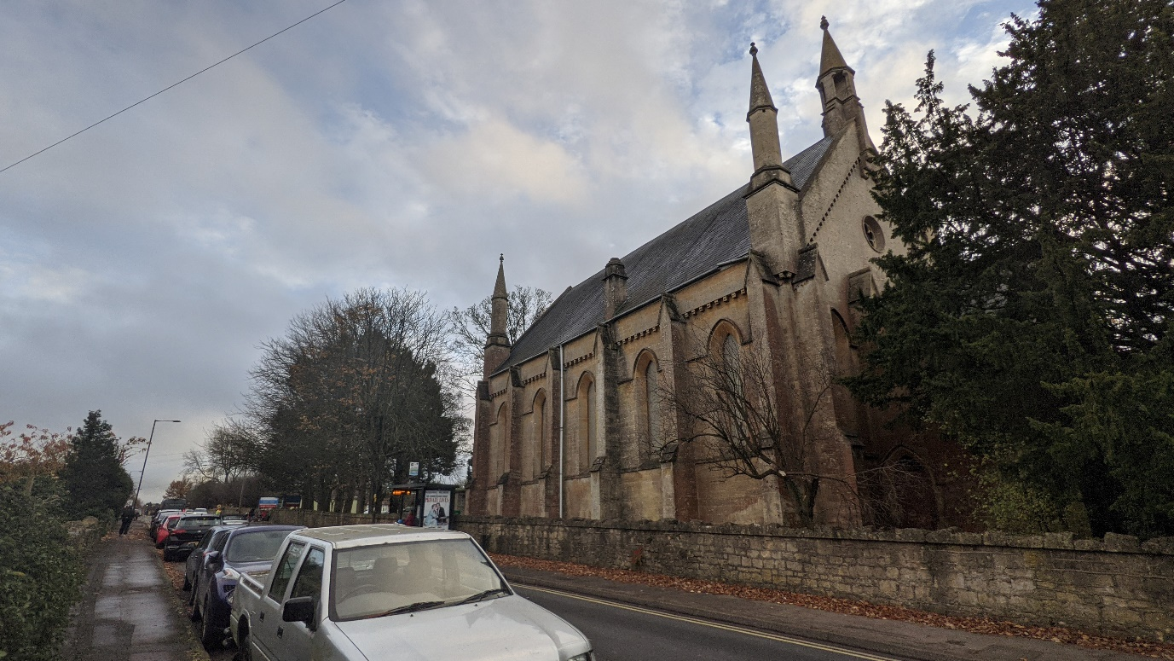
Prominent views of St Martin’s Chapel along Midford Road.

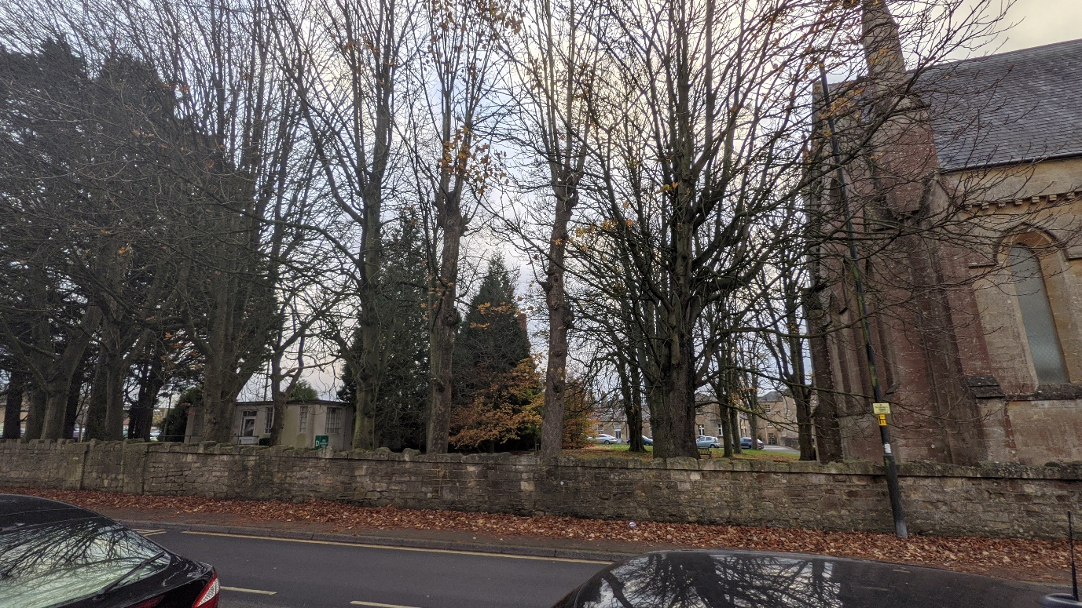
Interconnected views between the proposed site of development (left) and St Martin’s Chapel (right).

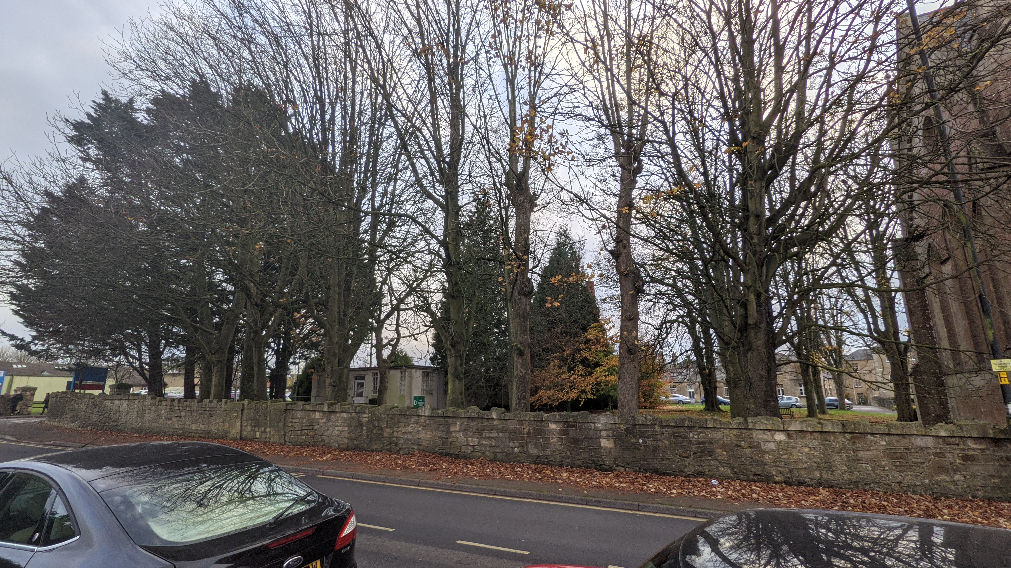
Interconnected views remain from further along Midford Road.

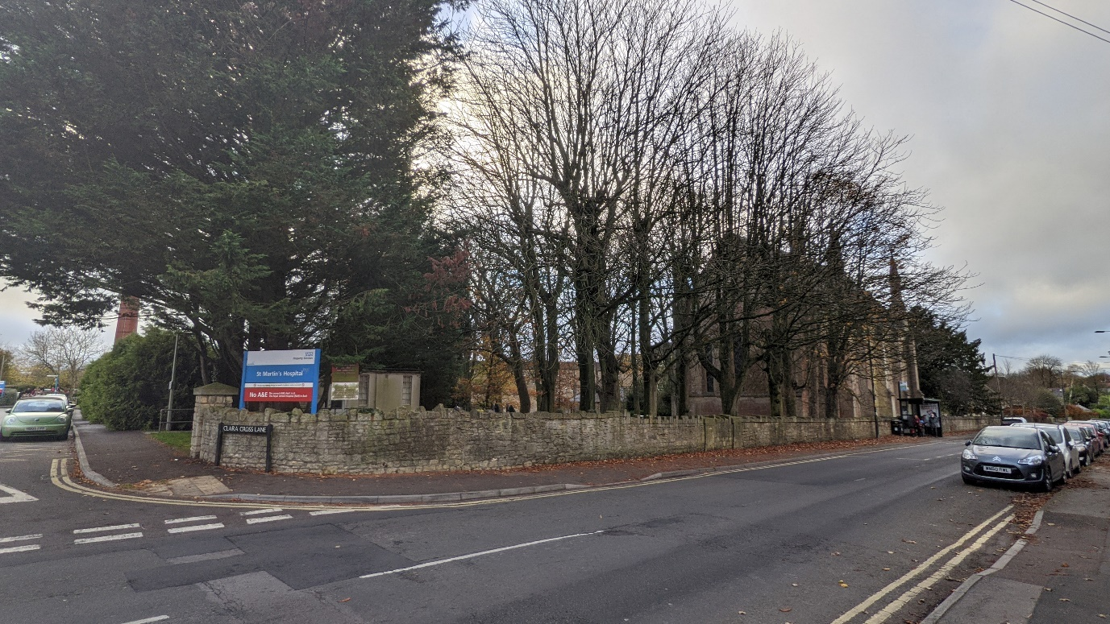
Views of the proposed site of development and the close proximity of St Martin’s Chapel from the junction of Midford Road and Clara Cross Lane.

