Planning Update
November 2021
News this Month
- B&NES’ new bid for second phase of Active Travel Route improvements – see 1.1
- Installation of ‘Sinking House’ above Pulteney Weir ahead of COP26 – see 1.3
- Controlled reopening of Cleveland Bridge to vehicles with 2m width restriction – see 1.4
- Revised Planning Committee date for Bath Quays North – see 2.1
- Opening of new Toppings bookshop in Grade II Friends Meeting House – see 2.3
- New application for affordable housing on Deadmill Lane – see 2. 4
- Application consented for wholescale slimite glazing installation at Grade II 6 Lansdown Place East – see 2.5
- Built Environment Day on 11th November at COP26 – see 3.1
- Government releases Net Zero Strategy in tandem with Heat and Buildings Strategy – see 3.3

1. B&NES Consultations and Projects
1.1 Council Bid for Improved Active Travel Route in Combe Down: A new bid for £890,000 to the Government’s Active Travel Fund Tranche 3 to improve a 1.5km walking and cycling route between Combe Down and the University of Bath is set for a decision this autumn. The proposals would include better facilities for pedestrians and cycles along the existing shared use path through Rainbow Wood and Claverton Down, as part of the Council’s active travel strategy:
- Improved road crossing facilities at three points with two new parallel crossings (similar to zebra crossings but with an adjacent cycle crossing point).
- Conversion of the existing zebra crossing on North Road, near Shaft Road, to a parallel pedestrian and cycle crossing.
- Junction improvements (pavement widening and a parallel pedestrian and cycle crossing at the Copseland/Oakley junction) to create safe crossing points to the University of Bath and Quarry Farm.
- Upgrade of shared route through Rainbow Wood with new hard surfacing.
1.2 B&NES to Support Home Energy Improvements: Residents are being offered an easy way to make their home more energy efficient and support the council’s net zero carbon ambitions. Homeowners with a joint household income of less than £30,000 a year, or those receiving income related benefits, could be eligible to apply for grant funded energy efficiency improvements to their property. To be considered eligible, homes should have an EPC of D or lower. Home improvements could include solar panels, cavity wall, underfloor, or loft insulation. The scheme is being promoted by B&NES Council’s Energy at Home service which provides information and signposting on energy related home improvements and grant and loan schemes: http://www.energyathome.org.uk/
1.3 ‘Sinking House’ Installation on Pulteney Weir Ahead of COP26 Meeting in Glasgow: On 31st October, a semi-submerged house was installed in the River Avon just below Pulteney Bridge by architects Stride Treglown. The project was created with Bath-based Format Engineers, local sculptor Anna Gillespie and Fifield Moss Carpentry. The art piece is intended to highlight the precarious point that has been reached in the climate emergency, ahead of COP26 talks on the same day. The house is constructed in timber and appears to be sinking into the river, with the figure of a person on the roof ‘clinging’ to the line that attaches the house to Pulteney Bridge. The architect has said that the piece is inspired by Greta Thunberg’s ‘Our house is on fire’ speech at the 2019 World Economic Forum, as well as increased and worsening flood events experienced in the UK and across Europe in recent years.
You can find out more about ‘Sinking House’ here: https://stridetreglown.com/initiatives/sinking-house/
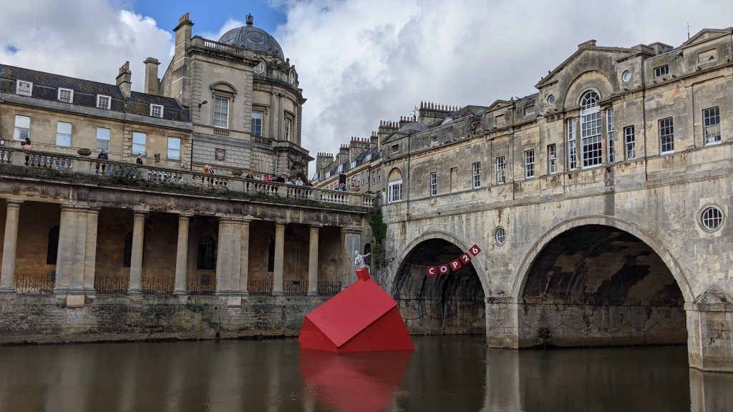
1.4 New Traffic Regulation Orders Public Consultation as Part of City Centre Security Scheme: Public consultation on a Traffic Regulation Order as part of the proposed city centre security scheme has now closed. The consultation received over 170 responses, and the results of the consultation are expected to be published in a report in December, which will include a recommendation on the final decision. Ahead of this, the council will continue to work with community and disability groups to ensure accessibility issues are addressed should the scheme be approved and the TROs implemented.
More information is available about the project here: https://beta.bathnes.gov.uk/bath-city-centre-security-traffic-regulation-orders-consultation/bath-city-centre-security-traffic
1.7 Bath MP Calls for Improved Bus Services: In a parliamentary speech, Bath MP Wera Hobhouse called for a statement on the Government’s plan to solve the bus driver shortage that is affecting local bus services. In addition to this, she has written to the West of England Combined Authority Mayor, Dan Norris, requesting a meeting where she will present the results of a recent survey put to residents in Bath and to discuss a plan looking ahead. The bus services now sit under the control of the West of England Combined Authority, run by Mayor Dan Norris, and central Government. The request comes ahead of the Bus Service Improvement Plan which is currently being prepared by WECA.
As part of the public survey:
- 74% of those who responded to the survey said they had a negative experience of buses in Bath.
- 41.7% said they had a ‘very negative’ experience.
- 32.3% said they had a slightly negative experience.
- 82.6% also said that they have experienced disruptions recently.
- Respondents cited lateness, reduced service and poor communication as the key issues.
This follows the submission of WECA’s “Prospectus” to central government’s City Region Sustainable Transport Settlement fund, with the aim of decarbonising transport, reducing private car use, and creating a sustainable transport network: https://www.westofengland-ca.gov.uk/wp-content/uploads/2021/10/West-of-England-Combined-Authority-CRSTS.pdf
1.8 Community Funding for Bear Flat Centre Improvements: The centre of Bear Flat in Bath is set to be enhanced thanks to a grant of £5,000 for repairs to the Grade II Victoria Diamond Jubilee drinking fountain, the first step in a wider project to make the area more attractive. Bear Flat Environment, a newly formed Charitable Incorporated Organisation, has been awarded the Neighbourhood Community Infrastructure Levy (CIL) grant by B&NES Council for the works to the fountain at The Gore.
The project is part of Bear Flat Association’s vision to make Bear Flat more welcoming, greener and safer for residents and to attract more trade for local businesses: https://bearflat.org.uk/a-vision-for-bear-flat-centre/
1.9 Cleveland Bridge Refurbishment Update: Cleveland Bridge has reopened to traffic under 2m in width from 25th October, but will remain closed to HGVs as extensive repair works continue. Traffic light controls and the two-metre width restriction are being put in place as part of the staged re-opening of the bridge. The bridge remains accessible to pedestrians and cyclists. Regular updates are available here: https://medium.com/cleveland-bridge-renovation

2. Bath Matters, Planning Applications and Developments
2.1 Bath Quays North: Application 20/04965/ERES for the mixed use redevelopment of the Avon Street Car Park site. UPDATE – The application is scheduled to go forward to Planning Committee in December.
You can read our response to the latest proposals on our website: https://www.bath-preservation-trust.org.uk/bpt-responds-to-latest-design-revisions-to-bath-quays-north-scheme/
2.2 The Scala: Application 21/04049/FUL for the redevelopment of the Scala site to provide mixed-use residential and student accommodation. UPDATE – The application is scheduled to go forward to Planning Committee on 17th November.
BPT welcomed the reduction of the height of the scheme and the use of a more sensitive pitched roof profile. However, we maintained strong concerns that the scheme constitutes speculative purpose-built student accommodation; there is no longer reference to the provision of student accommodation being exclusively for Norland College students. You can read our response in full on our website: https://www.bath-preservation-trust.org.uk/planning-application/the-scala-shaftesbury-road-oldfield-park-bath/
2.3 Friends Meeting House: The building was opened to the public on 30th October as Toppings bookshop. With two floors, as well as a purpose-built mezzanine, it is considered to be one of the biggest independent bookshops to open in decades.
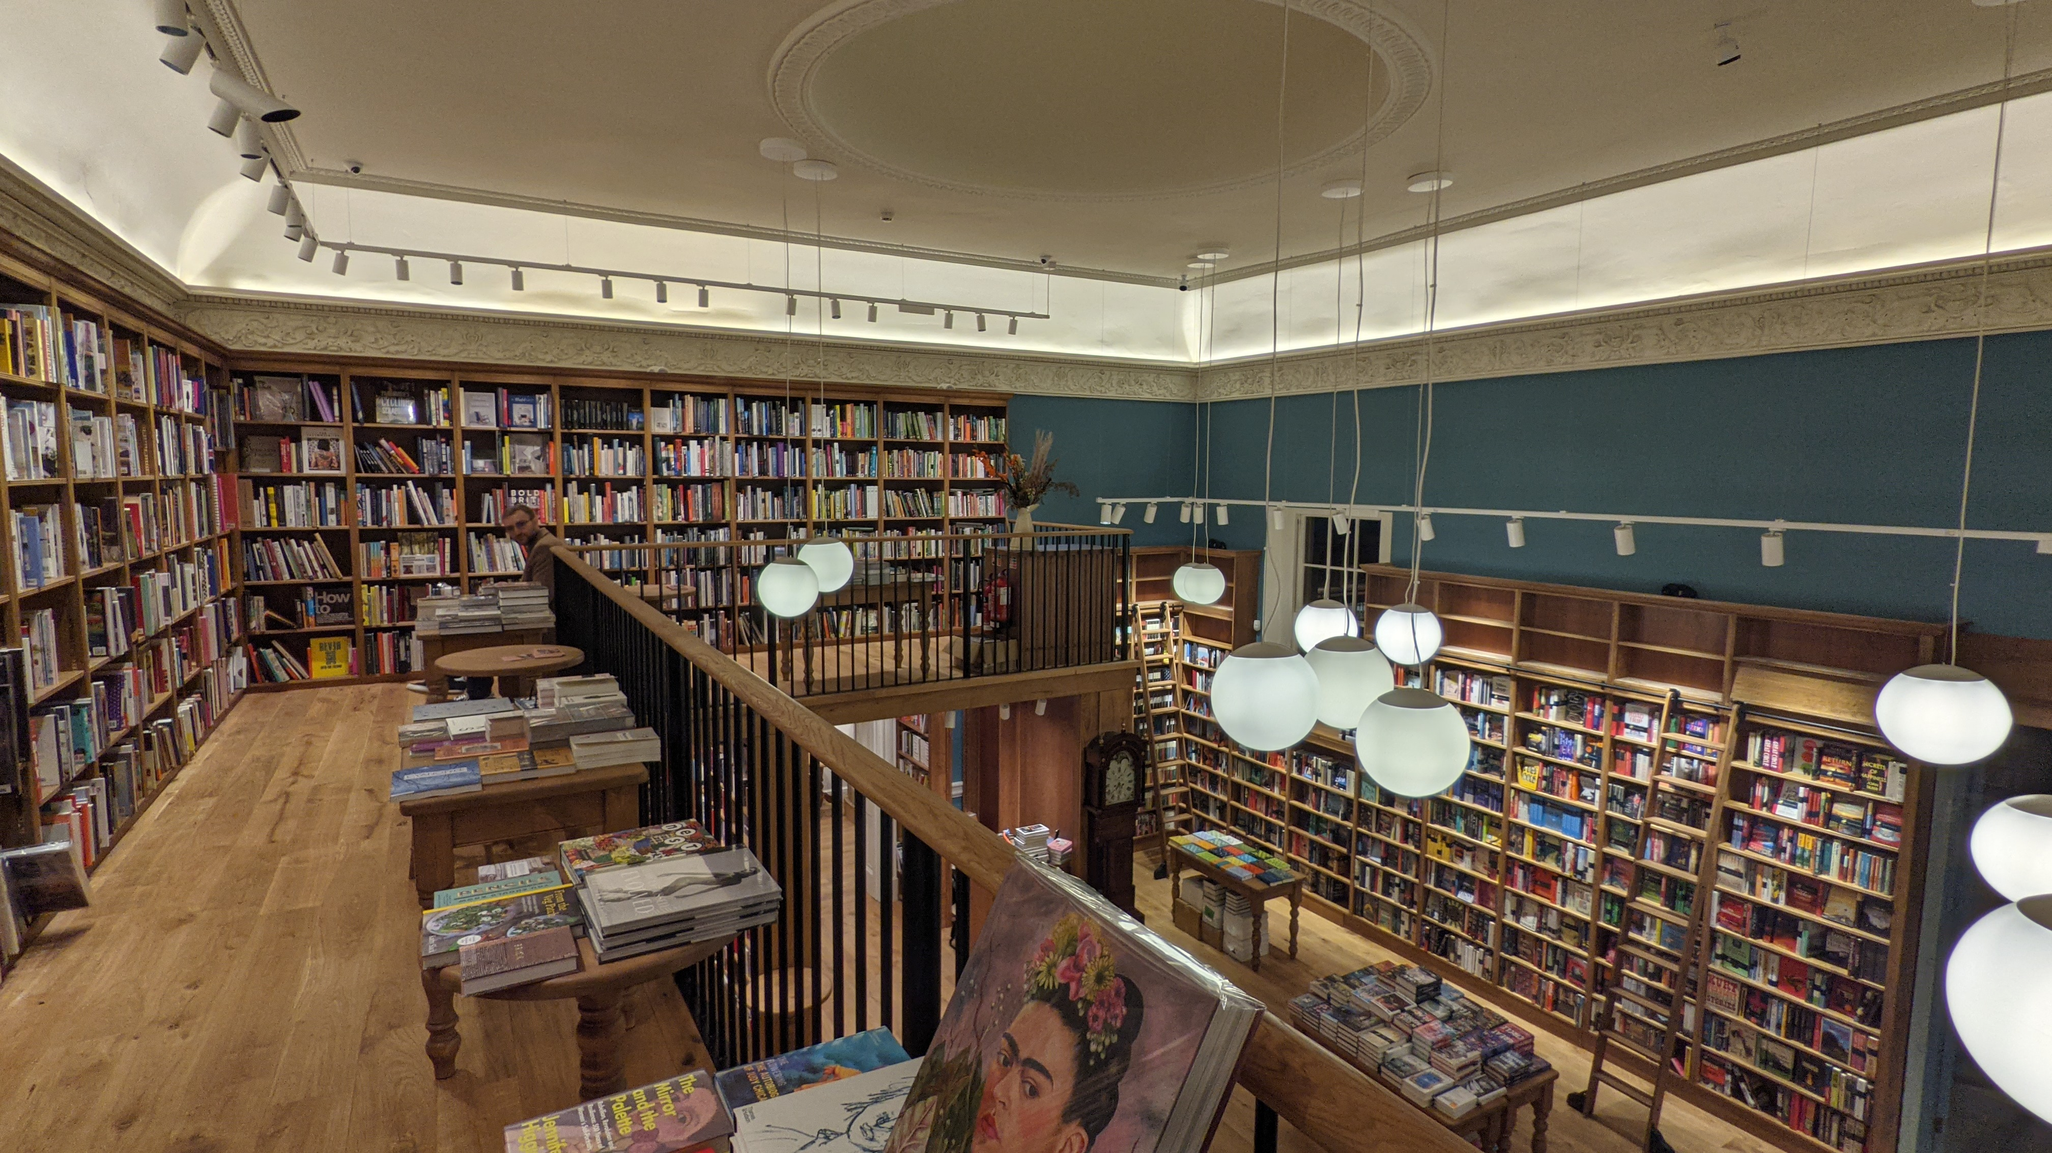
2.4 Deadmill Lane: Resubmitted application 21/04746/OUT has been submitted for the development of 15 affordable dwellings on a Green Belt site within Larkhall, on the rural edge of Bath. An earlier application for 18 affordable dwellings on the site was refused, and later dismissed at appeal on grounds of harm to the setting of the Bath conservation area, setting of the World Heritage Site, and the setting of Dead Mill, an adjacent mill building classed as a Non-Designated Heritage Asset. BPT originally objected to the principle of development on the site, which we felt would be of detriment to the green and open character of the Green Belt, and cause substantial harm to the picturesque landscape setting of the Bath conservation area and World Heritage site, and the setting of the AONB. We do not feel that our concerns have been adequately addressed by this new application, and therefore maintain our objection on the same grounds. You can read our previous objection in full via our website: https://www.bath-preservation-trust.org.uk/our-objection-to-deadmill-lane-application/
2.5 6 Lansdown Place East: Application 21/01238/LBA for the installation of ‘slimlite’ glazing across the front and rear elevations. UPDATE – The application has now been consented. In the Delegated Report, the case officer concluded that due to the poor condition of the mid- to late 20th century windows, “it is not considered that retention of single glazing is necessary for the significance of this listed building.” The marginal increase of glazing bar thickness, which BPT raised some concerns about, was considered to be acceptable. Considering the lack of extensive double glazing in listed properties seen in Bath, this application “will serve to explore the success of this type of glazing design” and will be inspected to assess potential benefits and impacts to the appearance and performance of the building once the windows have been installed.
You can read the decision in full here: https://www.bathnes.gov.uk/publisher/docs/DA898AF11A618A9E284835C70DCA5E1D/Document-DA898AF11A618A9E284835C70DCA5E1D.pdf

3. National News
3.1 COP26 Built Environment Day: The 11th November was Built Environment Day for COP26, this year being hosted in Glasgow. Urban buildings account for 40% of global carbon emissions each year, and it is estimated that 1.6 billion people living in cities will be regularly exposed to extremely high temperatures. The day saw the inauguration of The Clean Construction Action Coalition, a collection of companies from the architecture, engineering and construction industry who have committed to reduce the emissions produced from the built environment sector. The UK Green Building Council unveiled its much-anticipated Whole Life Carbon Roadmap - a tool to help businesses across the built environment sector measure and cut carbon from materials, processes, operation and demolition. The UK additionally launched its Urban Climate Action Programme, intending to provide £27.5m to at least 15 cities in developing countries across a three-year period to decarbonise public transport systems and energy systems, improve climate risk assessments and make waste management more sustainable.
3.2 Publication of the National Model Design Code: The National Model Design Code was published in July 2021 and is now available on the government website as a source of detailed guidance on the production of design codes, guides and policies and decision making, to promote successful design. It is noted that “this guidance is not a statement of national policy, however, the government recommends that the advice in this guidance on how to prepare design codes and guides is to be followed.” The National Model Design Code is therefore considered to be a material consideration in planning decisions and should be taken into account by local authorities when considering the following:
- How the design of new development should enhance the health and wellbeing of local communities and create safe, inclusive, accessible and active environments;
- How landscape, green infrastructure and biodiversity should be approached including the importance of streets being tree-lined;
- The environmental performance of place and buildings ensuring they contribute to net zero targets;
- The layout of new development, including infrastructure and street pattern;
- The factors to be considered when determining whether façades of buildings are of sufficiently high quality and;
- That developments should take account of local vernacular, character, heritage, architecture and materials.
You can read the most up-to-date edition of the National Model Design Code here: https://www.gov.uk/government/publications/national-model-design-code
3.3 Government Publishes Net Zero Strategy and the Heat and Buildings Strategy: On 2nd October, the Government revealed its Net Zero Strategy, setting out how the UK will deliver on its commitment to reach net zero emissions by 2050. The commitments made are intended to unlock approximately £90 billion in investment by 2030. As part of this, £3.9 billion of new funding will be provided for decarbonising heat and buildings, including the new £450 million 3-year Boiler Upgrade Scheme.
You can read the full Net Zero Strategy here: https://www.gov.uk/government/publications/net-zero-strategy
Alongside this, the Heat and Buildings Strategy has also been released, which sets out how the UK will decarbonise our buildings. Grants of £5,000 will be available to homeowners from April next year to enable them to install systems such as heat pumps that do not emit carbon when used. There is no mention made of the need to retain existing structures and their ‘embodied carbon’, and there is limited reference to the role of historic buildings (listed and unlisted) in reducing carbon emissions.
You can read the full Heat & Buildings Strategy here: https://assets.publishing.service.gov.uk/government/uploads/system/uploads/attachment_data/file/1026507/heat-buildings-strategy.pdf
3.4 SPAB Ongoing Research into Energy Efficiency of Historic Buildings: SPAB has been conducting ongoing research into whether older buildings are as thermally inefficient as frequently assumed and the effects on building performance of different approaches to upgrading the energy efficiency of older properties. Initial findings conclude that the thermal performance of solid walls is “frequently better than assumed” and use of ‘breathable’ insulation “minimises the risk of elevated moisture levels that can harm not only traditionally constructed (pre-c1919) buildings but their occupants’ health.”
You can read all findings (2012-2019) here: https://www.spab.org.uk/advice/research/findings
3.5 RTPI Releases Climate Crisis Guidance for Local Authorities: Jointly produced with the Town and Country Planning Association, RTPI has released a guide on how the planning system can help communities face the climate crisis. With the climate science clearly warning of the catastrophic impacts of climate change this new guide seeks to place the Government’s ambitions for net zero as well as building community resilience to severe weather at the heart of the planning system. The guide makes clear the vital importance of the planning system in designing places which cut carbon through the promotion of energy efficiency, sustainable transport and renewable energy.
You can access the guide here: https://www.rtpi.org.uk/media/9379/tcpa-rtpi-climate-guide_oct-2021_final.pdf

