21/04318/LBA
Sydney Gardens, Sydney Place, Bathwick, Bath, Bath And North East Somerset,
External alterations for the addition of foundation to low balustrade wall.
Object
Sydney Gardens is a Grade II late 18th century Designated Park and Garden, formerly a Georgian pleasure grounds now managed as a public park, situated within the Bath conservation area and World Heritage Site. The focus of this application is the Grade II* 1840 balustrade wall running along the western edge of the railway track, forming part of the original track bed established as part of the Bath section of the Great Western Railway line between Bristol and London by Isambard Kingdom Brunel. The balustrade is an important element of the Grade II and Grade II* assemblage of 1840 railway infrastructure, and the railway was seen as an opportunity to add to the park’s attraction by creating a ‘theatre’ in which passing trains could be viewed as part of the park’s landscape.
BPT believes that the railing design as previously permitted in application 19/03211/LBA (and unchanged by this application) is acceptable.
However, we have strong concerns regarding the accuracy of the section drawings provided, relating to the new concrete foundation and the base plinth of the balustrade. In Existing Section C-C, the existing base plinth is shown as a plain squared-off block sitting below ground level. The absence of any further details or sections indicating variability along the length of the balustrade suggests that this is true of the entirety. However, as shown in the photographs attached (see Images 1 & 2), the base plinth clearly sits above ground level with identifiable moulding details, indicating that it was designed to be seen as part of the whole balustrade. This is more accurately identified in the existing section on p.9 of the D&A Statement.
We highlight that more accurate proposed sections are provided as part of consented application 19/03211/LBA (see p.20 of the D&A/Heritage Statement, and the ‘existing/proposed park side elevation central bay’ documents). The existing sections within this application therefore do not appear to tally with the existing sections on the previous application. It is important that a decision is not made on the present application which appears to be based on inaccurate drawings.
We are therefore concerned that the proposed foundations would obscure an important element and harm the appearance of a Grade II* listed structure. We feel that the impact of these proposals may not have been appreciated, as drawings of the existing elevations do not show this detail and no drawings of the proposed elevations of the balustrade have been submitted. The proposed concrete foundation should be recessed further below ground level to ensure the historic detailing remains visible.
We note the comment from the Parks Department regarding the need for surfacing in soil and grass over the foundations in certain areas to match existing surface treatments, and this would bring the ground level even higher. This should be accounted for when establishing the depth of the concrete foundation in its entirety.
We strongly emphasise the need for a draining material between the concrete and Bath stone, to prevent water retention and associated frost damage to historic stonework in the winter months.

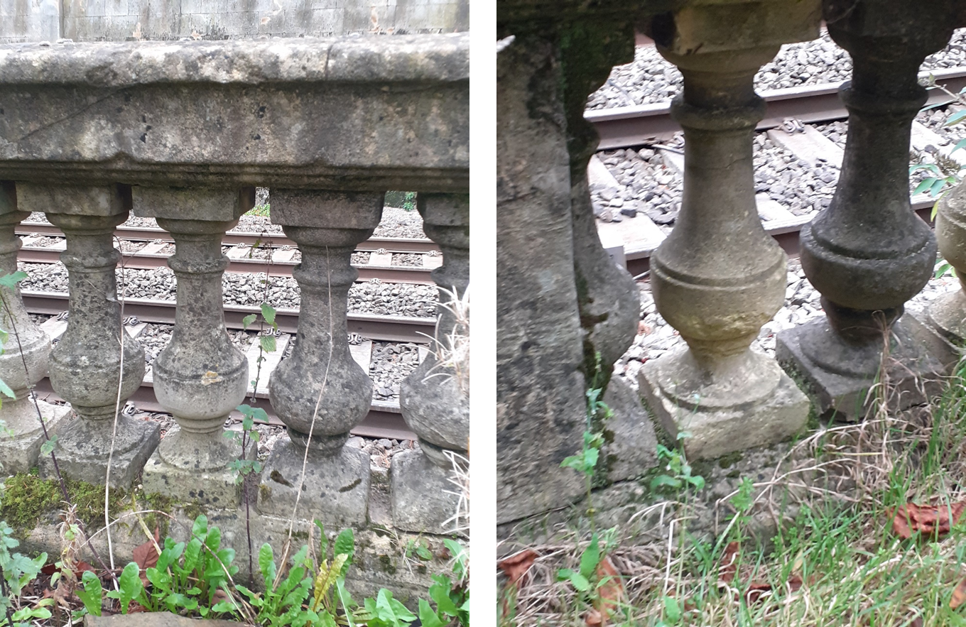
Image 1 (Section A) Image 2 (Section A)

We also wonder how effective the proposed measures would be in resisting applied lateral loading. Bed joints, presumed to be in a lime mortar, remain unreinforced between the head of the baluster and the top coping, and the base of the baluster and the plinth, as well as the vertical joint between the half baluster and the pier shaft (see Image 2). Any applied lateral loadings are likely to result in fracture at these points notwithstanding the proposed new ground beam etc. The effectiveness of the proposals should be verified by a specialist with appropriate experience of historic structures.
In response to application 19/03211/LBA, we previously emphasised the need for clarity on the existing condition of the balustrade balusters and coping, and any necessary repair or refurbishment works, to ensure that the balustrade is in a good enough condition to support the new railings. From observation, we are concerned about the existing condition of the stonework and the consequences of ongoing vegetation growth (see Images 3 & 4), and continue to stress the urgency of appropriate restorative works to prevent further stonework deterioration.
Considering the Grade II* significance of the structure and its associated cumulative significance as part of an important group of interconnected features that define Bath’s surviving railway heritage, we feel strongly that a detailed specification for the repair and cleaning of the coping stones and balustrade stonework is required, either as part of this application or an attached condition to any consent. This should be accompanied by regular maintenance in future to prevent the development of significant structural or material issues.

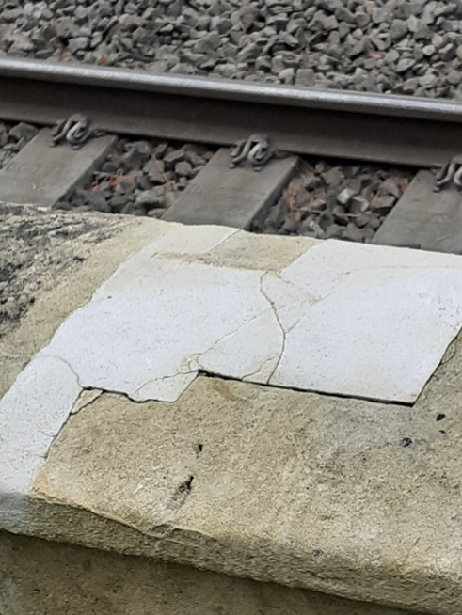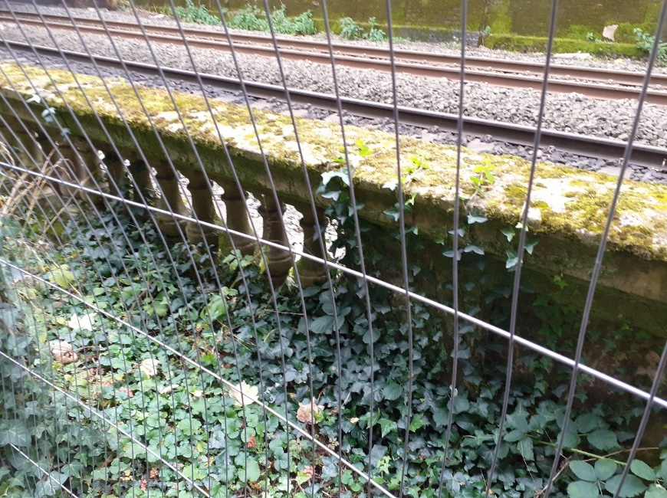
Image 3 (Section A) Image 4 (Section A)

Many Grade II* structures in this area, including the overbridges and adjacent retaining wall, are in a poor state of repair, and continued deterioration of a significant aspect of Bath’s railway heritage (see Images 5-8) is inevitable if this is not addressed. The amount of vegetation which has been allowed to grow from the stonework is potentially harmful and Network Rail should take this opportunity to improve their care of the listed structures through the gardens.
This application does not demonstrate sufficient understanding of the Grade II* balustrade, and the drawings and plans provided are inaccurate. The proposals would be of detriment to a listed structure contrary to the Planning (Listed Buildings and Conservation Areas) Act 1990, Section 16 of the NPPF, and Policies B1, BD1, CP6, D1, D2, D3, and HE1 of the Core Strategy and Placemaking Plan, and should be refused or withdrawn, or otherwise appropriately amended.

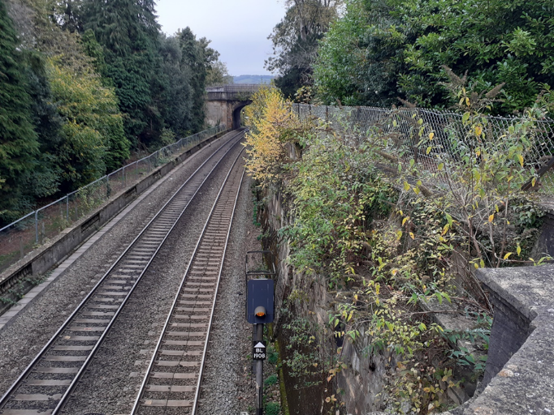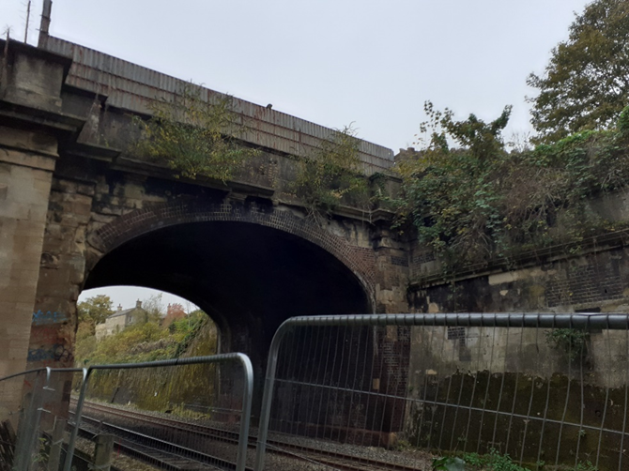
Image 5 (Section C) Image 6 (Beckford Road Bridge)

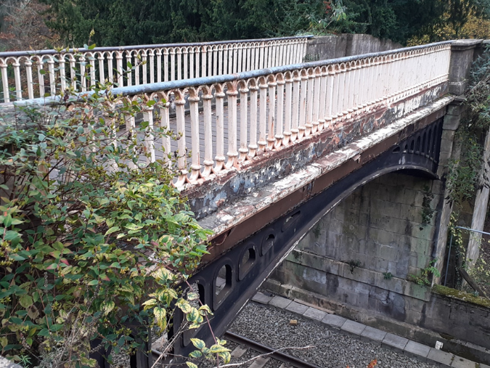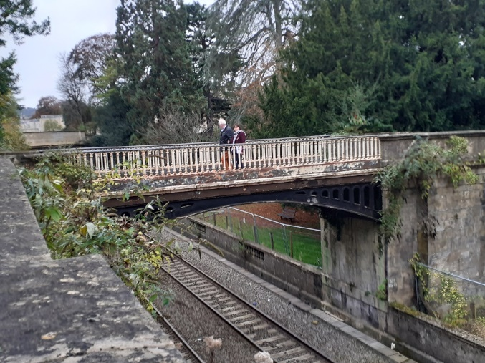
Image 7 (Sydney Gardens Overbridge) Image 8 (Sydney Gardens Overbridge)

