Planning Update Report
June 2021

Bath Preservation Trust Update
BPT’s museums are now reopen under coronavirus restrictions as of 17th May onwards. No. 1 Royal Crescent was opened on 2nd June by the new Mayor of Bath, June Player, and Thomas Sheppard, Chairman of BPT. It offers a brand-new immersive experience, allowing you to see life as it was lived in Georgian Bath during the late 1700s and has sold out across its opening week. Beckford Tower and Museum of Bath Architecture are available to book guided tours by appointment. The Herschel Museum is now open for pre-booked, self-guided tours with a brand-new audio tour available for adult visitors bringing the house to life with stories about how the Herschel family lived and worked in Bath, alongside a new audio-visual guide for children.
Tickets are available to book here: https://bath-preservation-trust.merlintickets.co.uk/collections/Events%20and%20tickets
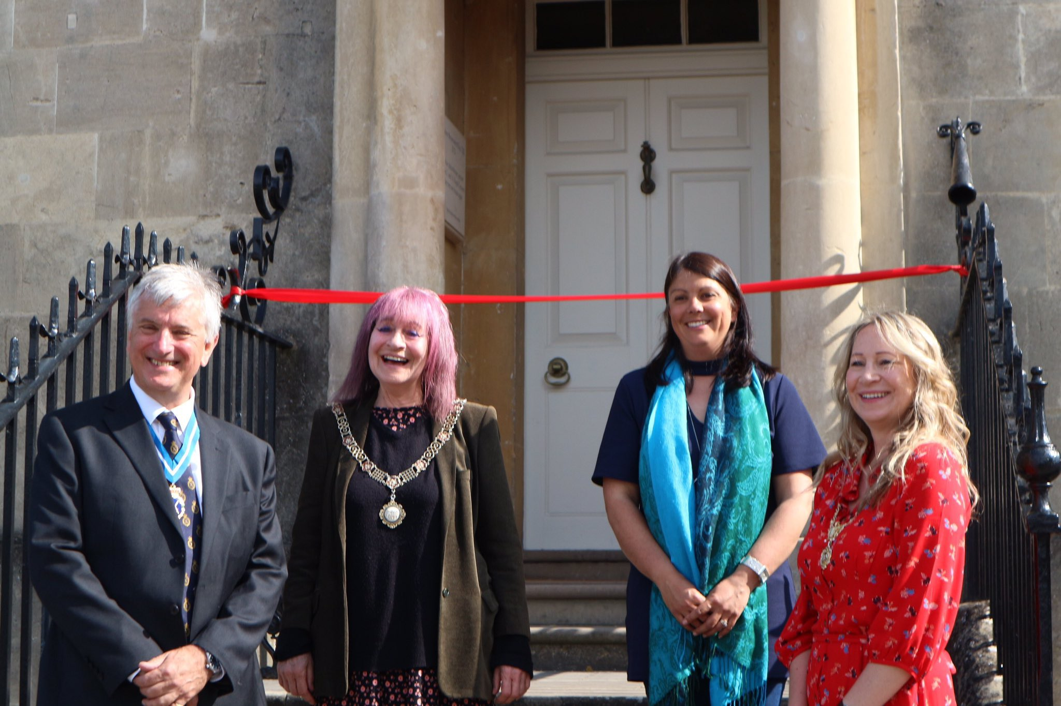

1. B&NES Council & Policy
1.1 City Centre Security Consultation: A second period of public consultation was open until 1st June, following the release of public feedback and the independent accessibility study. The proposals, in addition to an accessibility study and a consultation feedback report, were due to be considered at cabinet meeting on June 23rd. Consideration at a cabinet meeting has been pushed back to later in the year to allow for enough time to consider public accessibility alongside increased security measures.
You can access the project webpage via the council website: https://www.bathnes.gov.uk/services/streets-and-highway-maintenance/highway-improvements-traffic-management/bath-city-centre
The feedback from the first public consultation, and the independent accessibility study, can be accessed via the council website: https://beta.bathnes.gov.uk/bath-city-centre-security-consultation-update
1.2 Bath River Line Project: A webinar was hosted by B&NES Council on 21st May where proposals for Phase One of the Bath River Line Project were outlined (Newbridge to Bath Quays). The scheme is intended to be delivered over the next 5 years, with £3.5m secured from West of England Combined Authority and additional funding pooled from S106 Obligations.
Key themes from public consultation included:
- Feeling safe on the route, particularly in the evenings (low light).
- Smooth surfaces for ease of accessibility and other forms of transport (cycling, scooters, etc.).
- Good sharing between walkers and cyclists.
- Ease of access onto the path along the river.
- Celebration of nature and heritage.
- A place to live, for residents of nearby houses, and boats on the river.

Certain areas of the Line aim to prioritise certain aspects of the river (history, ecology, social role, and economic engine), to create a distinct series of destinations along the Line. The proposals would include the following parks: Brassmill Lane Park, Weston Lock Green, Kelson’s Field, Norfolk Crescent, and Green Park. Pinch points along the Line will be widened, although it was concluded to be unviable to widen the whole path due to spatial and land ownership constraints. Set back seating areas and river ‘balconies’ will be introduced to give spaces where people can get off the Line. A change in behaviour along the Line is also proposed, designating it a ‘slow way’ where slowest users come first and everyone using the Line should feel safe. The aim is not to discourage cyclists from using the Line, but to encourage slower speeds and more considerate use, and the use of landscaping to create meanders on previous ‘racing’ stretches. The path would be resurfaced to enable a smooth, consistent finish. Planting maintenance would be the mixed responsibility of volunteers and the Council’s Parks team.

There is an enthusiasm to be ambitious with historic interpretation and the provision of outdoor gallery space/art installations. A design approach is being considered in line with the existing Pattern Book, which is forming the basis for the creation of a new design guide/pattern book for the River Line area.

BPT raised the following comments in response to the proposals presented:
- We emphasise the need for a consistency and coherency of design across all three phases of delivery.
- How will newer, riverside developments be incorporated into the wider River Line scheme? How will developments (Bath Quays North) scheduled for completion before River Line delivery be factored in?
- There is a need to maintain an appropriate balance between riverside lighting levels and the distinctive, low level illuminated character of the Bath conservation area and World Heritage Site.
- It is positive to see that the scheme will draw on the established design and character of Bath as set out in the Bath Pattern Book, and the creation of a riverside-specific pattern book/design guide – will this have an opportunity for public consultation?
- Positive opportunity for enhancement of the biodiversity value of the river as a SNCI/part of the Green Infrastructure Network, in light of the Climate/Ecological Emergency.
- There is a need to secure a long-term management plan for the riverside path and parks to ‘tie-in’ support – possible consideration of supporting existing local residents groups, or creating new groups, to care for parks, as well as contributing to specific aspects of the scheme such as historical interpretation and art installations?
- Need for a consistent methodology to determine the key values of each particular ‘zone’ along the River Line to then inform interpretation.
- Potential strategy for permanent art installations?

You can access the proposals and the webinar recording via the project website: https://www.bathriverline.co.uk/
1.3 Council urges Government to Take Faster Action on Climate Change: A letter signed by a cross-party group of local and regional leaders including Councillor Kevin Guy and Councillor Sarah Warren highlights that local government plays a fundamental role in tackling climate change and asks the Government to provide more resources and power locally to make it happen. It calls on the Government to “go much further and faster and to recognise how local and regional government is key to our shared goal of achieving Net Zero.” It was written in response to mentions of ‘levelling up’ and Net Zero in the Queen’s Speech on 11th May and calls on the Prime Minister to engage with local and regional government on these interlinked issues.
1.4 New Monolith at Kensington Meadows: A locally-sourced 8-foot holed stone framing the Bath skyline is now in place at Kensington Meadows in Bath as part of a scheme to enhance the open space. The installation of the granite monolith comes ahead of work starting this summer to improve the play area with natural play features including a wooden climbing frame and slide, a willow tunnel and an agility trail. There will also be new play mounds with balance beams and junior football goals. The £60,000 Kensington Meadows Improvement Scheme is being carried out by Bath & North East Somerset Council following a community consultation held in 2018 about how people wanted to develop the green space for the future.
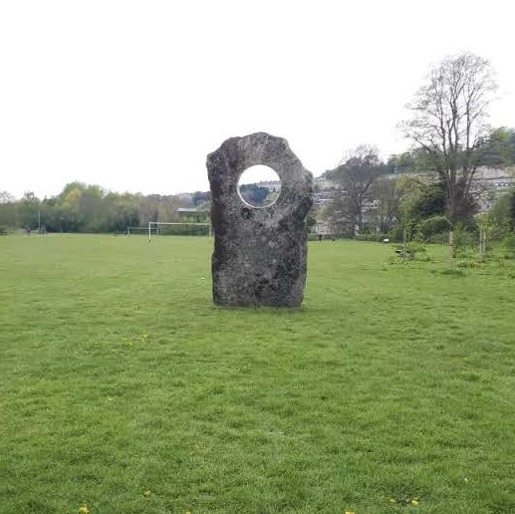
You can visit the Kensington Meadows webpage via the council website: https://www.bathnes.gov.uk/services/sport-leisure-and-parks/parks-green-spaces-information/kensington-meadows
1.5 Green Community Project Funding: Greater biodiversity and new habitats in Bath and North East Somerset are set to be encouraged by three green community projects in Clutton, Freshford and Corston that have won new funding. A community orchard will be established in Corston and will offer a wildlife haven in which people can enjoy nature, with the resulting fruit to be shared by the community. Freshford will also benefit from a new orchard and copse, while in Clutton there will be two new wildflower meadows and tree planting.
1.6 Stothert and Pitt Stone Quarry Crane Restoration: £1,900 has been awarded from the Caring for the Cotswolds Grant to the Bath Stone Quarry Museum Trust and project team to complete the second and final phase of works to restore the historic Stothert and Pitt Stone Quarry crane which worked in Box in Wiltshire. It is an important part of Box and Bath’s industrial history, believed to be the oldest surviving crane of its type manufactured in about 1864 by the famous engineering firm Stothert and Pitt. When restored, subject to planning approval, B&NES Council hope to site the crane on the former Newark Work Stothert and Pitt site which is being redeveloped as part of Bath Quays South. It will go on public display in Foundry Courtyard, an area previously used for testing cranes. The project is expected to be completed in late Autumn 2021.

2. Planning Applications, Developments and Bath Matters
2.1 The Min/Fragrance Group: Applications 21/01752/FUL & 21/01753/LBA for the change of use of the Mineral Hospital to a hotel with a new three storey extension to the rear. UPDATE – BPT feels that the new extension design is much more ‘polite’ within its ‘backland’ setting. The much-reduced size of the glazed link with the west wing of the Min is an improvement and visually ‘light touch’. We feel this is a significant improvement on the previous scheme.
2.2 Bath Quays North: Reserved matters application 20/04965/ERES for the Bath Quays North development on the site of the Avon Street car park. UPDATE - Natural England has indicated concerns with potential light spill onto the riverside, and particularly the oak tree at Ambury Place which is potential bat habitat. The tree uplighting on Ambury Place has therefore been omitted from the scheme, although the Ambury Place window reveals remain illuminated.
2.3 Midford Castle: Application 21/01555/FUL for the construction of a second agricultural barn and solar array on the site of the Grade I Midford Castle and Grade II* outbuildings. UPDATE - BPT has concerns about the significant height and scale of the proposed agricultural barn, and we do not feel that this has been suitably justified. Whilst we understand the need to reduce carbon emissions across the site, works should be consistent with the significance of a historically connected group of listed buildings. We feel this proposal would result in further harm to the group value and setting of the listed buildings. You can read our objection in full on our website: https://www.bath-preservation-trust.org.uk/further-proposals-for-second-agricultural-barn-and-solar-array-in-landscape-setting-of-grade-i-castle/
A new Renewable Energy System Design Report has now been submitted, clarifying the scale of the proposed solar PVT array as 560 panels with a gross area of 912.8m2. The agricultural barn is also intended to house ancillary equipment related to the array, including battery storage for electrical energy produced. The report summarises that the scale of the PVT array as proposed is the minimum required to meet necessary energy demands. It’s worth noting that no further sections or plans have been submitted, in relation to discussion at AP&P Committee.
The option of a ground source heat pump has been summarised as unviable due to “the increased electrical demand required from the grid and the extensive, multiple deep borehole drilling required to meet the kWth demand”. Previously, the option of a ground source heat pump was discussed and it was strongly recommended that an archaeological survey should form part of any ground works.
A holding objection has been submitted by the Ecology Officer due to the absence of an ecological survey.
2.4 Dick Lovett Site: Application 20/03071/EFUL for the mixed-use redevelopment of the Dick Lovett car dealerships to provide residential and student accommodation. UPDATE - Historic England continue to express concerns with the height of development (max 6 storeys) and maintains their comments as previous; “in our view, these changes do not significantly reduce the potential for the scheme to negatively impact on the Outstanding Universal Value of the World Heritage Site (WHS).”
Pegasus Planning proposed an offer of affordability levels of the proposed affordable dwellings, with 40% of the units at 40% discount to open market rental value, and 60% of the units at 20% discount to open market rental values. The Development Officer has summarised that the LPA’s Viability Assessment has concluded that the scheme could meet the affordable housing requirement (30%) at a 40% discount to the open market rental values. The Council has already given ground to the applicant that even with a 40% discount to the open market rental values, the cost of an affordable dwelling is still above the Local Housing Allowance caps, and therefore anything less than a 40% discount would not constitute truly affordable housing or qualify for housing benefit. A new affordability offer has come forward of 50% of units at 40% discount to open market rental value, and 50% of the units at 20% discount to open market rental values.
2.5 Regency Laundry: Application 20/03166/FUL for the redevelopment of the Regency Laundry to provide co-living accommodation. UPDATE - The application previously proposed no affordable housing on the basis that ‘co-living’ constitutes Sui generis use and would not trigger Policy CP9; average rooms would cost approx. £800-840 a month, and large studio rooms would cost approx. £840-920 a month. Case officers indicated that co-living would actually constitute C3 use and would be required to meet local affordable housing requirements. The applicant has previously offered 22 affordable units (20%) at 80% Discounted Market Rent as a planning benefit. A Viability Assessment submitted by the applicant indicates that it would be unviable for the scheme to offer any affordable housing; the offer has been increased to 31 affordable units at 80% Discounted Market Rent, which would still constitute 20% of total on-site units. Additionally, the applicant wishes to offer a financial contribution of £49,000 which the Council may put towards additional off-site forms of affordable housing.
2.6 Homebase: Application 20/00259/FUL for the redevelopment of the Homebase site to provide a new care community. UPDATE – Appeal inquiry APP/F0114/W/21/3268794 is scheduled to begin on 22nd June, running through 25th June, 28th-30th June, and 2nd July, with final inquiry evidence due by 25th May. BPT have submitted initial written representation and have registered to speak against the appeal.
The main issues in this case are likely to relate to:
- The effect on the character and appearance of the surrounding area, having particular regard to the City of Bath World Heritage Site (WHS) and special regard to the settings of a Grade II* listed building, 8-18 Norfolk Crescent, and the Bath Conservation Area (BCA).
- The effect on the living conditions of occupants of residential dwellings on Albert Crescent, Western Terrace and The Mews with regard to privacy and outlook.
The Inspector has additionally flagged concerns regarding:
- Consideration of ‘Shimbles v City of Bradford MBC [2018] EWHC 195 (Admin)’, ‘Bedford BC v SoS [2012] EWHC 4344 (Admin)’, and ‘Barnwell Manor Wind Energy Ltd v East Northants DC, English Heritage, National Trust and SSCLG [2014] EWCA Civ 137’ judgements and any others in relation to how harm to heritage assets and their settings should be weighted.
- The potential impact of proposed lighting on a Special Area of Conservation.
- Whether a financial contribution for local green space would be necessary to make the development acceptable in planning terms.
- Whether the personal care definition within the s106 would preclude C3 use.
2.7 Sulis Down: Permitted application 17/02588/EFUL for 171 residential units. UPDATE - The site has now been acquired by Countryside Properties. Variation application 21/02214/EVAR has been submitted with minor material amendments to the scheme, including the change of the proposed 2-bed flats to 2-bed houses (no external changes), change in design from semi-detached to detached along the central Green (plots 71-72, 98-105, & 118-125), and some swapping of material finishes between plots (rubble stone or render). 171 homes are to be delivered on the site, of which 40% will be affordable, in line with existing permit 17/02588/EFUL. Construction is due to begin in summer 2021.
2.8 Water Refill Units, City Centre: Applications 20/04732/FUL & 20/04734/FUL for water refill units on Bog Island and High Street. UPDATE - Works appear to have finished, but the water fountains are not yet publicly functional.

3. National Developments and News
3.1 Queen’s Speech: The Queen’s Speech on 11th May set out the Government’s agenda for 2021. Key news for heritage centred on the Government’s plans for ‘levelling up’, the confirmed introduction of changes to the planning system through a new Planning Bill. A package of UK-wide funds, including the Levelling Up Fund, Community Renewal Fund, and Future High Streets Fund, intend to complement and support the levelling up agenda.
The new Planning Bill will include the following points:
- Changes to local plans to “provide more certainty” for communities and developers over permissible development and “what is permitted where”, and the inclusion of clear land allocations.
- Bringing forward proposals for zoning, which may see planning permission accelerated for housing in “growth” areas.
- A new levy to replace existing methods of securing developer contributions towards infrastructure and affordable housing with “simpler, faster procedures”. This is intended to replace the current system of section 106 agreements and CIL payments, and would be levied on the scheme’s completion.
- Acceleration of certain aspects of planning decision-making to create faster procedures for producing local development plans and approving major schemes.
- Digitisation of the planning system to facilitate public engagement.
- Simplification of the framework for environmental assessments for developments.
- The Environment Bill will mandate “biodiversity net gain” in the planning system. A duty will be introduced for developers to deliver an uplift in biodiversity through their schemes.
- A possible increase in powers for “locally-led” development corporations, including those led by local authorities, to “support growth and regeneration” in local areas.
A Levelling Up White Paper is expected later in the year.
You can read BPT’s response in full via our website: https://www.bath-preservation-trust.org.uk/planning-reforms-risk-inadvertent-weakening-of-environmental-and-heritage-protection-local-democracy-and-community-engagement/
RTPI Press Release: https://www.rtpi.org.uk/news/2021/may/planning-must-be-the-cornerstone-of-the-levelling-up-agenda/
CPRE Press Release: https://www.cpre.org.uk/news/planning-bill-could-bulldoze-environment-bill-warns-cpre/
BD Online Press Release: https://www.bdonline.co.uk/news/architecture-reacts-to-queens-speech/5111775.article
TCPA Press Release: https://www.tcpa.org.uk/news/tcpa-responds-to-queens-speech
Heritage Alliance Summary: https://www.theheritagealliance.org.uk/wp-content/uploads/2021/05/The-Queens-Speech-11-May-2021-Our-Summary.pdf
3.2 Testing Programme for National Model Design Code: The 14 local planning authorities in England selected to apply the new National Model Design Code (NMDC) to their areas in a six month trial have been announced. The national design code seeks to ensure that new developments are "beautiful, well-designed and locally-led". Developments should also fit in with local character. The government explained that the code gives local planning authorities a toolkit of design principles to consider for new developments, such as street character, building type and façade. It also features environmental, heritage and wellbeing factors. MHCLG received more than 70 Expression of Interest submissions to test the NMDC from across all regions of England. The 14 councils were chosen to ensure there is a geographical spread and a range of development types, such as an urban conservation area, town centres and rural settlements, taking part. Each pilot receives a £50,000 grant to carry out the project.
The 14 councils as selected

3.3 Technical consultation on consequential changes to permitted development rights: As part of reforms to the planning system, the introduction of Commercial, Business and Service Use Class E was intended to facilitate the increased flexibility of building use, particularly on the high street, to enable high streets to adapt to changing circumstances and support our economic recovery. However there are a number of permitted development rights in respect of those uses, as well as outstanding references to former use classes. These existing rights continue to have effect until 31 July 2021. The third stage of reform is therefore to make necessary consequential changes throughout the General Permitted Development Order. This technical consultation therefore now sets out detail of the proposed consequential changes to existing permitted development rights and invites comment from local authorities and communities.
Consultation closed on 3rd June. You can access the consultation documents via the government website: https://www.gov.uk/government/consultations/technical-consultation-on-consequential-changes-to-permitted-development-rights/technical-consultation-on-consequential-changes-to-permitted-development-rights
3.4 The Town and Country Planning (General Permitted Development etc.) (England) (Amendment) Order 2021: An amendment to the T&C Planning Act was introduced on 31st March, including:
- A new Class MA (in Part 3 of Schedule 2) to allow change of use from commercial, business and service uses (Use Class E) to residential dwellings (Use Class C3) under permitted development rights subject to conditions and limitations. Transition arrangements for Article 4 directions restricting change of use from offices to residential dwellings are in place until 31 July 2022.
- Amendments to Class M (in Part 7 of Schedule 2) to increase the size of extensions and building height allowed under permitted development rights for schools, colleges, universities, prisons and hospitals, subject to conditions and limitations.
- Addition of Commemorative Structures to Class B (in Part 11 of Schedule 2) confirming extra protections for unlisted statues, memorials or monuments.
You can access the amendment document via the government website: https://www.legislation.gov.uk/uksi/2021/428/made/data.xht?view=snippet&wrap=true

