Planning Update Report
April 2021
1. B&NES Council & Policy
1.1 Local Plan Partial Update Options Consultation: All comments submitted as part of B&NES Council’s consultation will be made available via the consultation portal, shortly after the end of the consultation period. B&NES Council is currently progressing towards the production of a Draft Plan.
There will be further opportunities to contribute ideas and comment on the content of the Local Plan Partial Update, as the update progresses towards becoming adopted (being official council policy). These are the stages to adoption:
Local Plan progress to adoption
Date | Action
Spring 2021 | Formal consultation on Draft Partial Update (Regulation 19)
Autumn 2021 | Plan submission for examination by a planning inspector, appointed by the Secretary of State (Regulation 21)
Winter 2021 to 22 | Examination hearings
Spring 2022 | Adoption

The timetable for stakeholder engagement for the Milsom Quarter masterplan is currently in progress by B&NES Council. It has been confirmed that BPT will have a chance for consultation both as part of the public consultation on the Local Plan Review, and as part of stakeholder engagement as part of the masterplan evidence gathering. An update is anticipated by May/June 2021.
1.2 City Centre Security Consultation: More than 500 consultation responses have been received by the council and these will now be taken into account, along with the recommendations from an accessibility adviser. These results and any proposed modifications and mitigations to the original consultation proposals will be progressed in accordance with the Council's decision-making process. The final decision will be made at Cabinet, following this decision, any Traffic Regulations Orders will be advertised.
Updates are available via the project webpage: www.bathnes.gov.uk/citycentresecurity
1.3 Active Travel Scheme Consultation: The consultation period has now closed. A decision will be made at the Council Cabinet meeting in May.
All consultation documentation can be accessed via the council’s website: https://beta.bathnes.gov.uk/active-travel-schemes
1.4 Launch of the Clean Air Zone: The UK’s first charging Clean Air Zone (CAZ) outside of London launched in Bath on 15th March to drive down harmful pollution and protect public health. From midnight, polluting vehicles will be charged £9 or £100 a day to drive in the centre of Bath. Private cars and motorbikes will not be charged. The scheme is designed to tackle Bath’s air pollution problem which is chiefly caused by vehicle emissions. Several areas in the city regularly exceed the legal limits for nitrogen dioxide (NO2) pollution – even during lockdown. Daily charges will apply seven days a week, midnight to midnight, all year round for chargeable vehicles with a pre euro 6 diesel or pre euro 4 petrol engine. The council secured £9.4 million of funding from government to help residents and businesses, including coach companies and taxi drivers, to replace polluting vehicles with cleaner, compliant ones. The council has set up a scheme to help owners upgrade their vehicles and already more than 500 businesses have applied. A further £1.58 million has helped local bus operators to retrofit fleet not already compliant in the zone.
You can read the full press release via the council’s website: https://newsroom.bathnes.gov.uk/news/vehicle-charging-scheme-cut-air-pollution-launches-bath
1.5 Works to Milsom Street: Milsom Street is set to receive a refresh ahead of lockdown restrictions being eased with the reopening of non-essential shops and the reintroduction of outdoor dining scheduled for April. The entire length of Milsom Street, together with a section of New Bond Street, will be resurfaced between Monday 29 and Wednesday 31 March, and heritage repairs will be carried out to replace missing kerbstones. To minimise disruption the work will take place overnight between 7pm and 6am with Milsom Street closed to all traffic. The parklets installed in Milsom Street last summer are being temporarily removed but will be returned in time for the planned reopening of stores on Monday 12 April. The cycle stand at the top of Milsom Street will also be removed. It’s being donated to a local school and will be replaced later this year to further increase cycle parking on the street.
You can read the full press release via the council’s website: https://newsroom.bathnes.gov.uk/news/milsom-street-closed-resurfacing-ahead-high-streets-reopening
1.6 The Vacant Units Action Project: An exciting project to breathe new life into vacant shops and buildings in high streets across Bath and North East Somerset has been awarded £500,000 from the West of England Combined Authority’s Recovery Fund. It is proposed to use empty properties in Bath for creative projects and pop-up businesses, with satellite projects in Keynsham and Midsomer Norton to follow across a two-year programme. The project will be delivered by B&NES Council as part of its High Streets Renewal programme. Further match funding and in-kind support will be provided by the council and Bath BID. The project follows on from a successful pilot to celebrate local retail during the lead-up to Christmas 2020 when the council worked with local artists to promote 12 vacant properties in Bath city centre by animating shop windows, encouraging two pop-up shops to open.
You can read the full press release via the council’s website: https://newsroom.bathnes.gov.uk/news/ps500k-funding-bring-empty-high-street-properties-back-use
1.7 Cleveland Bridge: Work starts this spring on the £3.8m project to repair Bath’s historic Cleveland Bridge in April, when scaffolding is erected, ahead of the bridge closing fully in May. It is expected to take seven months to complete the work, although a timeline cannot be confirmed until the scaffolding goes up and engineers are able to inspect the bridge. Motorists are being urged to pre-plan their journeys to avoid disruption caused by the closure or consider if other modes of travel around the city can be used. Pedestrians and cyclists will still be able to cross the bridge while it is closed to vehicles.
You can read the full press release via the council’s website: https://newsroom.bathnes.gov.uk/news/motorists-advised-pre-plan-journeys-ahead-major-road-closure-0
1.8 Bath River Line Project: The Bath River Line project has been launched by B&NES Council to develop a landscape masterplan for a linear riverside park, set to follow a 10km stretch of the River Avon from Batheaston to Newbridge and connect up Bath’s riverside green spaces. The park aims to reveal lesser-known parts of the river, connect communities, create a high-quality route for walking and cycling, and enhance biodiversity and natural habitats. The council is asking residents to visit the new Bath River Line website which features an interactive map, where people can share what they like and don’t like about the proposed route and submit their memories and photographs of the river.
Comments are invited before April 16 and will help inform the final design of the scheme. In early summer, there will be a consultation on the final design and residents will be invited to have their say before a funding bid is made to the West of England Combined Authority in the autumn.
You can access the Bath River Line website here: http://www.bathriverline.co.uk/
1.9 B&NES £2m Fund Secured to Cut Carbon Emissions in Buildings: B&NES Council was one of a number of local authorities which secured several successful bids from the Department for Business, Energy and Industrial Strategy, each of which will accelerate carbon reduction. Two grants were together awarded £950,000 from the Public Sector Decarbonisation Scheme to reduce the carbon emissions of a council-owned residential care home at Charlton House, and for the installation of heat pumps as part of the refurbishment of the Cleveland Pools which is being delivered by the Cleveland Pools Trust with the support of the council. Reducing the carbon emissions of both homes and commercial buildings in the district is one of the three key priority areas where action across the district by all organisations is needed to tackle the climate emergency, alongside transport and increasing renewable energy.
You can read the full press release via the council’s website: https://newsroom.bathnes.gov.uk/news/more-ps2m-funding-secured-cut-carbon-emissions-buildings
You can see the latest updates on the Cleveland Pools project via their website: https://www.clevelandpools.org.uk/news
1.10 Bath Police Station: Avon and Somerset Police are moving forward with plans for refurbishment at Lewis House to provide a new police station for neighbourhood officers in the centre of the city. A lease agreement has now been reached between Avon and Somerset Police and B&NES Council. The next steps will be to submit a planning application for the work to alter the building to meet the needs of the police and council employees, as well as improving the visibility of the services for the community. The One Stop Shop service will continue to operate from the ground floor.
You can read the press release via the council’s website: https://www.avonandsomerset-pcc.gov.uk/news/2019/03/new-police-station-for-bath/
1.11 B&NES Council Green Home Grants Scheme: B&NES Council has won additional funding from the government to expand its Green Home Grants Scheme and is now for the first time extending the scheme to houses with a D energy rating as well as those with an E, F, or G rating. Residents of qualifying properties, whose household’s joint annual income is less than £30,000, can apply for a council Green Affordable Warmth Grant to upgrade their home with double glazing, insulation or low carbon-heating. Improvements for homeowners will be fully funded with an average of £10,000 available, while renters and owner-occupiers may be eligible for upgrades with landlords receiving up to two-thirds of the cost, up to an average of £5,000, dependent on the work required. The upgrade required for a property will be identified by a property retrofit assessment visit.
Householders can apply for funding and find further information about energy retrofitting and further grants available on the council’s website: https://www.energyathome.org.uk/
You can read the press release via the council’s website: https://newsroom.bathnes.gov.uk/news/green-affordable-warmth-grant-extended
1.12 Bath Alliance for Transport and Public Realm: A new website has been launched by Bath Alliance to publish articles, papers and videos to provide background, current ideas, opinion and inspiration on urban transport issues that are relevant for Bath. Examples of how other cities are addressing the same issues that challenge Bath are also included in regular updates. The Alliance has released its Transport Manifesto, with a vision of Bath as “A beautiful city in a green setting, with vibrant public spaces, a historic centre free of all but essential traffic, clean air and excellent transport infrastructure” and the following objectives:
- Public Realm and Movement Strategy delivered.
- Connectivity maintained.
- Mobility enhanced.
- Congestion reduced.
- Air quality restored.
- Heritage and environmental assets preserved and enhanced.
You can access the website and subscribe to updates here: https://bathalliance.org.uk//
You can read the Manifesto in full via their website: https://bathalliance.org.uk/wp-content/uploads/2019/09/Alliance-Bath-Transport-Manifesto-4-April-2019.pdf
1.13 Lantern Restoration at Walcot Steps: Two new LED lanterns have been fitted on the Grade II* Walcot Steps to improve lighting and access. The works have been funded by the World Heritage Enhancement Fund, with support from B&NES’ Historic Environment team and lighting engineer. The lights are now on site and working, and form part of a wider scheme by the Enhancement Fund for the historic relighting of the city, including previous works to Great Pulteney Street lanterns and overthrows and Cavendish Place overthrows.
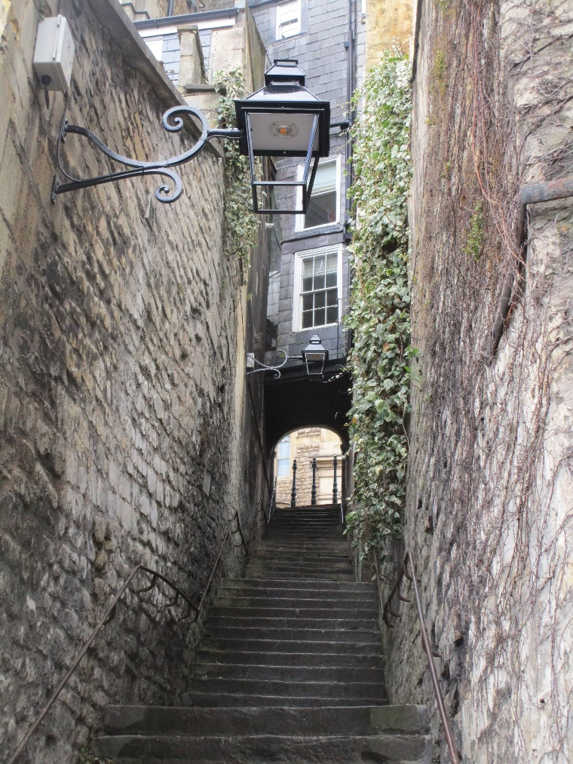

2. Planning Applications, Development and Bath Matters
2.1 The Royal Mineral Water Hospital (The Min): A public exhibition for pre-application proposals for an extension to the rear of the Grade II* Royal Mineral Water Hospital (The Min), as part of a wider scheme to refurbish the building as a hotel, has been launched online, along with other consultation activities including a leaflet drop. The exhibition summarises the scale of works and includes CGIs of the latest iteration of the scheme. Following consultation with BPT, the design has been developed further in consultation with B&NES Council and Historic England. The glazed link between the extension and the west wing has now been omitted, with only the glazed walkway between the first floors retained to enable access. The scale of the green wall on the Parsonage Lane elevation has also been significantly reduced and is proposed to be limited to the ground floor as cladding for the ground floor plant room. The elevations would be Bath stone ashlar. Public access to the site would be “managed”, with guided walks and tours to the two Roman mosaics discovered on the site.
You can access the exhibition online: www.theminexhibition.co.uk
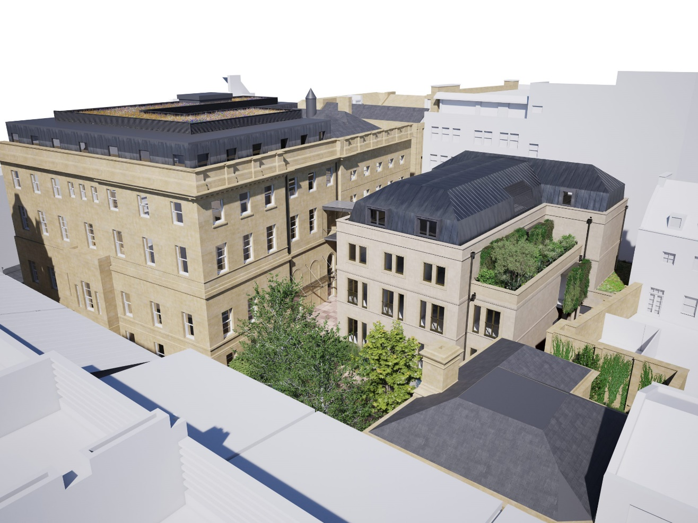
Architecture graduate from the University of Bath, Harry Wyatt, is currently undertaking to create a digital model of the Min as it stood at the time of its opening, in partnership with Paul Thomas and Bath Medical Museum. The exterior model has been completed, and the interior modelling is due to start with the support of local funding, and will form the framework for residents’ stories and memories. Paul Thomas is seeking funding for further stages, which will be the production of a guided virtual tour, short videos and integration into a website as an interactive video.
The stage 1 exterior model is available for viewing here: https://3dwarehouse.sketchup.com/model/7cbb4b3d-7305-48c1-9c4e-2f955c0edab8/The-Min-Model-Stage-1
2.2 Old King Edward’s School: Planning applications 21/00695/LBA & 21/00692/VAR have been submitted for the change of use of the Grade II* Old King Edward’s School to a hotel with a restaurant and bar on the ground floor, and associated material changes to the interior. This follows on from a string of permitted planning applications for change of use to a mixed use hotel, restaurant, and bar from 2010 onwards. The mid-18th century building has been vacant since the 1986 and is currently on the Heritage at Risk register.
The Trust continues to advocate for this fine building to be brought back into a use appropriate to its special architectural and historic interest to secure its upkeep and survival. In 2013, we previously encouraged the refurbishment of the building for public use, but had some concerns about the proposed scale of bar use on the ground floor. We have submitted our response reiterating the need to bring this building into use and our ongoing concerns regarding the potential loss of internal historic fabric and fittings (see attached).
You can read our consultation response in full via our website: https://www.bath-preservation-trust.org.uk/new-planning-application-could-secure-future-of-grade-ii-old-king-edwards-school/
You can read the Trust’s latest statement about the future of the Old King Edward’s School via our website: https://www.bath-preservation-trust.org.uk/bpt-open-letter-to-bnes-about-future-of-old-king-edwards-school/
2.3 Bath Quays North: Reserved matters application 20/04965/ERES for the mixed-use redevelopment of the Avon Street car park. UPDATE – Consultation feedback have been publicly received from Historic England and B&NES Council’s Historic Environment team and Urban Design Officer.
Historic England has voiced reservations regarding the proposed approach to the roofscapes and the lack of architectural articulation or variation of the elevations. It claims that the flat, biodiverse roof treatment would sit ‘uncomfortably’ within landscape views and would like to see a roofscape that better sympathises with either the roofscape of the nearby Georgian city, or the post-industrial character of the riverside. The riverside elevation has the visual effect of a single building of monolithic scale and fails to create visual interest or character.
B&NES’ Historic Environment team have expressed concern regarding the ‘disparate mix of structures at roof level’ which would be clearly visible in wider landscape views. The use of biodiverse roofs, including tree planting, would be of sharp contrast with the urban character of the Georgian city’s roofscape and would appear incongruous. The riverside elevations are felt to be of a monumental and over dominant appearance out of character with its riverside setting, due to repetitive building heights, overemphasis on the development’s horizontality, and a lack of material variation. The Urban Design officer similarly felt that the horizontal appearance of the scheme is overemphasised, resulting in a ‘squat’ appearance.
The former coach park next to Bath College has been repurposed as a temporary car park in advance of the closure of Avon Street car park.
You can read the Trust’s full consultation response to the planning application via our website: https://www.bath-preservation-trust.org.uk/bath-preservation-trusts-comments-on-revised-bath-quays-north-development-plans/
2.4 Friends Meeting House: Planning applications 20/04801/LBA & 20/04802/AR for the addition of four wall-mounted signs and the repainting of the portico fascia went before Planning Committee on 10 March. Councillors voted to support the officer’s recommendation to refuse both applications. Councillors felt that the signage proposed indicated a lack of confidence in the business and the building, and would have liked to see more negotiation with the case officer regarding signage options. Whilst the reuse of the Meeting House was agreed to be positive, the proposed signage would not be visually acceptable and would cause unnecessary harm to historic fabric. There was particular concern regarding the painting over of the ‘Friends Meeting House’ sign on the portico fascia, which was felt to form an important part of the building’s historical narrative.
You can read the Minutes of the Committee meeting on the 10th March via the council’s website: https://democracy.bathnes.gov.uk/documents/g5622/Public%20minutes%2010th-Mar-2021%2011.00%20Planning%20Committee.pdf?T=11
Works have now begun at the Meeting House, with the opening of the blind doorway. It is anticipate that Toppings will open in its new premises before Christmas 2021.
2.5 Homebase Site, Pines Way: Application 20/00259/FUL for the redevelopment of the Homebase site to provide a new care community. UPDATE - Appeal APP/F0114/W/21/3268794 has been submitted following refusal of application 20/00259/FUL at Planning Committee on 16th December. The application was refused on grounds of excessive height, bulk and massing within the World Heritage Site, use of inappropriate materials, and resulting harm to the character and appearance of the surrounding area and harm to the OUV of the World Heritage Site, The development was concluded to have an unacceptable adverse impact on the levels of residential amenity currently enjoyed by neighbouring residents, and would result in an unacceptable loss of trees which would not be appropriately mitigated by replanting. The proposed volume of parking would not be policy-compliant. The appellant argues that an increased density and bulk of development on the site would be required to meet the requirements of Policy SB7, and the development would sit within the height parameters set out in the Bath Building Heights Strategy and would be of a similar scale with other contemporary precedents in the area such as Pinesgate. The use of brick and metal cladding were intended as part of an “industrial design approach” and were considered largely acceptable by B&NES Council’s conservation team and urban design officer. Appeal consultation ends on 22nd April.
2.6 Bath Cricket Club: Works ongoing. Recent development updates can be found via their website: https://www.bathcricket.com/news/development-update-31st-jan/
2.7 Stadium for Bath/The Rec: Planning application 21/00962/VAR has been submitted for the extension of permission for the temporary eastern stand until 30th May 2022. This is due to social distancing restrictions impacting on the length of the rugby season.
2.8 165 Rush Hill, Odd Down: Application 20/01795/FUL for the construction of eight dwellings following the demolition of the garage on Rush Hill. UPDATE – This application has been permitted. Nine dwellings were originally proposed on the site, but this was reduced to eight dwellings, with the removal of one of the ‘courtyard’ dwellings. The ‘Edwardian’ terrace along the roadside was simplified in design to remove the bay windows and utilise a modest coursed natural stone façade and would be set back in small front gardens. The main concern was regarding the residential amenity to the north of the site for Somerdale View residents. The case officer considered the gap of 22m to be sufficient to avoid any ‘harmful’ overlooking, and the use of privacy screens and the natural difference in topography would also mitigate impact. It was concluded that the density would be typical of the suburban character of the area.
2.9 Hartwells Garage Site, Newbridge Road: Application 19/01854/OUT for the redevelopment of the Hartwells Garage site to provide mixed residential and student accommodation. UPDATE - Appeal APP/F0114/W/20/3258121 for a mixed-use development of housing and student accommodation on the site of Hartwells Garage was allowed on 22nd March. The planning inspector felt that the delivery of 104 dwellings on the site would exceed the local policy housing target of 80-100 dwellings, and therefore this would not exclude the provision of student accommodation. The mass and deep plan of the proposed housing blocks were acknowledged to be different to the surrounding Victorian houses on Newbridge Road, but the inspector concluded that the scheme would be an improvement on the current Garage site which had been identified as a ‘detractor’ to the local area by B&NES Council. The inspector felt that the design was reminiscent of ‘mill buildings’ historically located along the riverside and would offer a successful visual transition between the residential Victorian houses and the Maltings industrial estate. The provision of 1-2 bed apartments and student cluster flats was felt to be a policy-compliant housing mix. The inspector considered there was still need for student accommodation in Bath, and this development would contribute towards this need.
The Trust spoke against the proposals at public inquiry. You can read our appeal statement and planning application consultation response via our website: https://www.bath-preservation-trust.org.uk/hartwells-site-appeal-inquiry/
2.10 19 Park Street, Lansdown: Application 20/00189/FUL for the erection of a mews flat over garages to the rear of Grade II Park Street terrace. UPDATE - Appeal APP/F0114/W/20/3251612 for the erection of a mews flat over the top of permitted garages to the rear of the Grade II Park Street terrace was dismissed on 22nd March. The inspector noted that the development would read as a mews development, for which there was no historic precedent to the rear of Park Street. The size of the proposed patio was felt to be too narrow to be of practical use as an appropriate amenity space, and would therefore fail to provide an appropriate level of amenities for new and future occupiers. The inspector concluded that the limited public benefit of this small scale development would not outweigh the harm to the heritage assets.
2.11 Field on Corner with Ferndale Road and Deadmill Lane: Outline application 20/00491/OUT for the construction of 18 dwellings on an undeveloped site along Deadmill Lane. UPDATE – Appeal APP/F0114/W/20/3260800 for the erection of 18 affordable dwellings on an undeveloped site within the landscape setting of the Bath conservation area and World Heritage Site was dismissed on 1st March. The planning inspector felt the development would be overtly urban in appearance and therefore at odds with the open, semi-rural character and appearance of the character area and erode a part of Bath’s landscape setting. This would result in adverse harm to the special landscape qualities of the World Heritage Site and would not preserve or enhance the appearance or character of the landscape setting of the conservation area. Similarly, it was felt that the development would harm the rural setting of Dead Mill, a historic mill building identified as a local landmark and a Non-Designated Heritage Asset (NDHA) of local significance. Whilst the inspector acknowledged the development would be of some public benefit in providing affordable housing, this benefit would not outweigh the total harm to the World Heritage Site, conservation area, and the setting of a NDHA.
2.12 Cedar Park Care Centre: Applications 20/02818/LBA & 20/02817/FUL for the erection of a single and two storey extension in place of an existing extension to the south of a pair of Grade II semi-detached villas, went to Planning Committee on the 7th April. The case officer’s recommendation was to permit on the grounds that the public benefit would outweigh the less than substantial harm to a listed building. The Trust spoke against the application on grounds of harm to the significance and setting of a pair of listed buildings, and failure to preserve or enhance the character and appearance of the conservation area in wider public views. Councillors discussed the need for high-quality care facilities in the local area, and felt that the current extension could not be appropriately retrofitted to meet expected care standards. The proposals were felt to be an improvement on the previous 2017 scheme (see 17/01543/LBA) due to the reduction in height of the two-storey link building. Councillors voted unanimously to delegate to permit both applications.
2.13 All Saints Church, Upper Weston: Application 19/03731/FUL for the erection of a single storey erection to the north-west corner of the Grade II church to create a new access with meeting rooms and kitchenette, and associated landscaping including the relocation of the Grade II* Dr William Oliver Tomb. UPDATE - The application has been permitted. The scheme had been amended with regards to the design of the proposed extension; the final extension design would be more symmetrical with a slight reduction of glazing to the west elevation. The east elevation has been reduced in size to retain part of the external vestry wall and the two light traceried windows. No change was made to the scale, footprint, or position of the extension. The case officer concluded that the moderate/high levels of less than substantial harm to the listed building and graves and the wider conservation area would be outweighed by the proposed public benefits stemming from the development, including improved access to the church and churchyard, enhancement of community/congregation facilities, ecological enhancement works to the churchyard, and restoration works to the Grade II* Dr William Oliver tomb.
2.14 The Jewish Burial Ground, Combe Down: Application 21/00538/LBA for the creation of a garden store in the Grade II Jewish Burial Ground. UPDATE – The application has been permitted. The proposed garden store is intended to free up the historic cottage structure to be restored as an exhibition space to engage visitors about the history of one of Bath’s diverse minority groups, which has been supported by the Trust. Restoration works to the cottage have already been granted listed building consent. Funds have been secured for restoration works to the cemetery, including the repair of one of two rare chest tombs, repairs to twenty headstones most at risk of delamination, the restoration of the entrance gates, and creation of a level paved access.

4. National Developments and News
4.1 National Planning Policy Framework and National Model Design Code Consultation: A new consultation was launched on 30th January for revisions to the NPPF, to implement policy changes in response to the Building Better Building Beautiful Commission “Living with Beauty” report. The consultation also sought views on the draft National Model Design Code, which provides detailed guidance on the production of design codes, guides and policies to promote successful design.
The Trust has now submitted its formal consultation response. We are supportive of the strengthening of policy for sustainable development and the protection of the natural and built environment. We welcome increased emphasis on the need for beautiful, well-designed places and the use of tools such as local design codes and masterplans to inform development proposals and reflect local character. We emphasise that Local Authorities will need additional resources and skills-based training to be able to undertake and deliver these character assessments with appropriate community consultation. We additionally feel that further clarity is needed regarding the role of civic and amenity societies as consultees throughout the plan-making process.
You can read the Trust’s formal consultation response via our website: https://www.bath-preservation-trust.org.uk/the-trust-has-responded-to-the-national-planning-policy-framework-and-national-model-design-code-consultation/
The consultation period has now closed, but all consultation documents can be accessed via the government website: https://www.gov.uk/government/consultations/national-planning-policy-framework-and-national-model-design-code-consultation-proposals
You can read the RTPI’s consultation response via their website: https://www.rtpi.org.uk/consultations/2021/march/rtpi-response-to-mhclg-nppf-and-national-model-design-code-consultation/
4.2 Green Homes Grant: The Green Homes Grant has been scrapped after having reached only 10% of the 600,000 homes the chancellor promised would be improved. Originally extended to run until March 2022, the scheme was stopped on Wednesday 31st March and the cash allocated to a separate insulation fund run by councils and targeted at lower-income households. The Green Homes Grant was originally launched in September 2020 with a £300m allocated budget, but struggled to gain enough interest from homeowners in some areas whilst being overwhelmed by demand in other parts of the country. Some installers went out of business because payments were delayed by stringent spending checks. The parallel insulation scheme administered by local authorities is running more smoothly but ministers still need to create a new programme to nudge able-to-pay home owners into improving their insulation for the UK to hit its climate change targets. There is no sign yet what that new programme might look like, or when it might happen.
4.3 Permitted Development Rights: The Housing, Communities and Local Government (HCLG) Committee has declared that it will examine the government’s approach to Permitted Development Rights (PDR) in England. Last summer the government outlined a number of changes to PDR, including allowing a range of commercial buildings to be turned into residential units without going through the full planning process, and upwards extensions to post-war buildings. The committee said the inquiry would examine the effects these PDR expansions have had – and will continue to have – on the planning system and the government’s targets for new homes and economic growth. The results at a local level will also be examined, such as the ability of local authorities to plan development holistically, developer contributions and the provision of services to meet changing local needs. Changes to PDR set out in the government's planning white paper Planning for the Future will also be part of the inquiry.
The committee has invited submissions on a number of issues, including the consequences of PDR for the quality of housing and its effects on the involvement of local communities in the planning process.
The deadline for submissions is Friday 30 April 2021. More information can be found via the government website: https://committees.parliament.uk/work/1131/permitted-development-rights/
4.4 Carlton Tavern, West London: The reconstruction of a 1920s pub which was demolished without obtaining planning permission has been completed, and is scheduled to reopen next month. The building was being considered by Historic England for Grade II listing as a well-preserved example of a public house with minimal alterations, and the only survivor of the Blitz on its street, when it was unexpectedly demolished by developers in 2015. Westminster City Council issued an "unprecedented" enforcement notice ordering the developer to "recreate in facsimile the building as it stood immediately prior to its demolition". The notice prevented the site from being sold until the pub had been rebuilt. The developer appealed over both the refusal of planning permission for its proposed replacement with residential flats (with ground floor bar), and the order to rebuild the pub. A public inquiry rejected both appeals in 2016, but extended the time allowed for rebuilding to 24 months. Works eventually began in 2017.
You can read more about the case here: https://www.theplanner.co.uk/news/carlton-tavern-must-be-rebuilt-planning-inspectorate-rules
4.5 Heritage Counts: The new Heritage Counts report Know your Home, Know your Carbon: Reducing Carbon Emissions in Traditional Homes was launched at Heritage Day on 24th March. The report, published by Historic England on behalf of the Historic Environment Forum, aims to support and empower the people who look after our historic buildings. It shows the power of small behaviour changes and the need to recycle and reuse our buildings first to reduce carbon emissions. The report found that carefully retrofitting our historic homes could save up to 84% in carbon emissions, and recommends easy lifestyle and retrofit changes such as installation of secondary glazing, loft insulation, draught proofing, turning the thermostat down, and regular repairs to joinery and stonework/brickwork.
You can read Heritage Counts via Historic England’s website: https://historicengland.org.uk/content/heritage-counts/pub/2020/hc2020-know-your-home-know-your-carbon/
4.6 Heritage Recovery Plan 2021: The Historic Environment Forum Covid Task Group, working with Historic England, has published a Heritage Recovery Plan for the sector. The Plan looks forward to the period from April 2021 as the latest national lockdown comes to an end and covers four themes: re-opening, resilience, skills and return to growth with actions for Government and for the sector. The Task Group is now working with HEF members and the wider heritage sector to take forward the actions set out in the Plan.
You can read the Heritage Recovery Plan in full via their website: https://historicenvironmentforum.org.uk/wp-content/uploads/2021/03/Heritage-Recovery-Plan-FINAL-100221-.pdf
4.7 Art Newspaper’s 2020 Visitor Numbers Survey: The Art Newspaper's annual survey shows how the pandemic had a devastating impact on museums around the world, with the overall attendance of the world’s 100 most- visited art museums dropping by a staggering 77% in 2020 - from 230 million in 2019 to just 54 million as museums worldwide were forced to close. Many of the UK’s major museums rely heavily on international tourism: the British Museum’s audience was made up of 77% foreign visitors for the 2019/20 financial year, while the National Gallery’s is usually “around 60% annually”. Provisional data from the UK’s Office for National Statistics (ONS) shows that, in the second quarter of 2020, when the UK went into its first lockdown, the number of visits by overseas residents fell by 96% compared to the same period in 2019.
You can read the full results of the survey via their website: https://www.theartnewspaper.com/visitor-figures-2020
4.8 Heritage Day 2021: The Heritage Alliance’s annual Heritage Day took place virtually across Wednesday and Thursday 24th – 25th March. The event was used to launch Historic England’s latest Heritage Counts publication, produced on behalf of the Historic Environment Forum and which focused on reducing carbon emissions in traditional homes. There were also key note speeches from the Heritage Alliance’s CEO, Lizzie Glithero-West, Historic England Chair Sir Laurie Magnus, and new Minister for Heritage, Caroline Dinenage MP. The Department for Digital, Culture, Media & Sport (DCMS) intends to publish an updated Heritage Statement in the course of the coming year. This would outline DCMS’ refreshed priorities for heritage around sector recovery and resilience, the contribution of heritage to the Government’s levelling up agenda, climate change, and diversity and inclusion.
4.9 Virtual Planning Committees to End by 6th May: The government has told English local authorities that they should not to expect to continue holding planning committee and other virtual meetings after 6 May, but to prepare instead to restart in-person meetings. Junior local government minster Luke Hall circulated a letter with local councils confirming that there would be no extension to temporary regulations, as this would require a change to primary legislation and would place the system under further strain.
A motion – calling for the council to join other authorities in urging government to legislate for virtual meetings to be a permanent option – was approved at a full gathering of B&NES Council. It was argued that councillors, officers and the public had made great progress in developing the skills necessary to hold them and that – long term – this technology could attract a more diverse range of councillors and officers and allow a greater flexibility of meetings for councillors and members of the public which could be used alongside more traditional face-to-face meetings. The full council meeting agreed that the leader should write to relevant ministers and local MPs and raise the issue with colleagues such as parish councillors.

