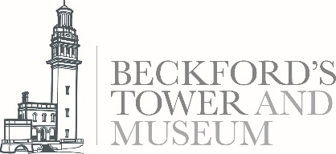
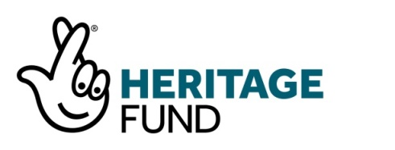

Embargoed until 30 December 2019

At-risk Beckford’s Tower secures early National Lottery support and starts fundraising campaign
Beckford’s Tower overlooking Bath, owned and operated by Bath Preservation Trust, has received initial support* from The National Lottery Heritage Fund for the redevelopment project ‘Our Tower’: Reconnecting Beckford’s Tower and Landscape for all.
Development funding of £422,600 towards a development programme of £480,778 has been awarded by The National Lottery Heritage Fund to help Bath Preservation Trust progress their plans to apply for a full National Lottery grant of £2.5m at a later date to complete the project.
With funding made possible by National Lottery players, the extensive project aims to bring William Beckford’s complex and creative life to a wider audience by sharing stories of his writings and collections, his inherited slave wealth, his sexuality and exile through a new visitor experience. The project will also restore the architectural masterpiece of the Tower built for Beckford in 1826.
The Tower is in urgent need of conservation, having been added to the National ‘At Risk’ Register in 2019. In addition to addressing this conservation need and creating a new museum experience inside the building, our project will also restore the Grotto Tunnel, improve access to the cemetery and create new footpaths, produce interpretation and trails for the lost Tower landscape and use renewable energy to illuminate the Tower for all to see and enjoy.
Thanks to this funding, work to develop the project and to continue our engagement with the local community will start in 2020 with, if successful in securing the full National Lottery grant, major capital works in 2022. Bath Preservation Trust will liaise closely with the Landmark Trust which manages a holiday apartment within the Tower, throughout the project.
Already an important Bath landmark familiar to residents and commuters alike, the aim is to inspire an appreciation for the extraordinary and contemporary story of William Beckford and his building, encouraging more people to explore and enjoy it and its landscape, establishing a communal sense that it is not just Beckford’s Tower, it is Our Tower.
Caroline Kay, Chief Executive of Bath Preservation Trust comments:
“We’re delighted that we’ve received this support thanks to National Lottery players. Grade I Beckford’s Tower is one of our most significant 1820s British buildings and its setting on an escarpment above Bath, with its bright golden lantern, has been admired by generations. It’s great to know that we are a step closer to preserving it for another century and connecting this national treasure to an even wider audience. It is now that the hard work can begin not least of fundraising for our share of the costs of the full project and securing the Tower’s future, for which we will aim to raise £1m.”

Notes to editors
Bath Preservation Trust was set up in 1934 to safeguard the historic city of Bath. Bath is a UNESCO World Heritage Site, and the only complete city in the UK afforded World Heritage Status. The purposes of the Trust are: to encourage and support the conservation, evolution and enhancement of Bath and its environs within a framework appropriate both to its historic setting and its sustainable future, and to provide educational resources, including museums, which focus on the architectural and historic importance of the city. The Trust receives no statutory funding and is supported by visitor income, grants, legacies, donations and around 1400 members who share a passion for the city and its environs.
The Trust runs four accredited museums in Bath and has the support of over 200 volunteers. www.bath-preservation-trust.org.uk
Follow @BathPresTrust and @Beckfordstower on Twitter, Facebook and Instagram

About The National Lottery Heritage Fund
*National Lottery Heritage Fund grant applications over £250,000 are assessed in two rounds. ‘Our Tower’: Reconnecting Beckford’s Tower and Landscape for all has initially been granted round one development funding of £390,900 by The National Lottery Heritage Fund, allowing it to progress with its plans. Detailed proposals are then considered by The National Lottery Heritage Fund at second round, where a final decision is made on the full funding award of £2,508,900.
Using money raised by the National Lottery, we Inspire, lead and resource the UK’s heritage to create positive and lasting change for people and communities, now and in the future. www.heritagefund.org.uk.

Follow @HeritageFundUK on Twitter, Facebook and Instagram and use #NationalLotteryHeritageFund
Further information: contact Janey Abbott, Communications Officer at Bath Preservation Trust on 01225 338727 or jabbott@bptrust.org.uk.

