Press Release
2 October 2019

THE OLD ONES ARE THE BEST –
BATH’S RESTORED STREET SIGNS WIN NATIONAL AWARD

The conservation and restoration of historic incised and/or painted street signs across Bath is a winner at UK’s Georgian Group Architectural Awards 2019.

Repairing and reinstating historic street signs in Bath began in 2010, and soon became an on-going programme, organised and funded by the Bath World Heritage Enhancement Fund, a partnership between The City of Bath UNESCO World Heritage Site, Bath and North East Somerset Council (B&NES) and Bath Preservation Trust (BPT).
By the end of 2018, in the 50th anniversary of the Bath city-wide conservation area, fifty-two street signs had been completed; more are planned.

The City’s World Heritage Chairman, Professor Barry Gilbertson explained:

“Our project restores the chisel-marks of the architects and builders of the 18th Century who understood the importance of good signage. The street signs are generally at first floor level – not so much for the Georgian pedestrians, but for carriage-drivers, sitting up at that level, with horse reins in hand, who could see the signs clearly, even without the benefit of any street lighting on dull days and gloomy nights.”

The work entails sensitive cleaning of the signs, carefully preserving the existing original letters, meticulously matching lime mortars and inserting new pieces of Bath stone for repair. Missing or worn letters are re-carved and re-painted. Signs that are not incised but simply painted on to the wall are re-painted in the existing style, using Keim mineral paints to match the existing colours.

B&NES’s Councillor Ruth Malloy says:

“We restore a handful of street signs each year and every time the impact on our World Heritage Site city is remarkable, for residents and visitors alike. For the project to have been recognised by The Georgian Group – arbiters of the best conservation work in the country – is fantastic. The WHEF is one of those vital organisations which diligently organises conservation and improvements to pieces of Bath’s heritage, using a dedicated group of volunteers and drawing on the expertise of specialists. This sort of accolade makes our achievements all the more worthwhile and I urge anyone interested in supporting us, with time or money, to get in touch via the website. Partnership contributions from residents make such a difference to the projects we take on.”

BPT’s Ms Ainslie Ensom, Project Manager and Administrator for the World Heritage Enhancement Fund, says:

“We’re so proud to have won this award, and proud that another project, financially supported (with seed funding and mould-making) by our City of Bath World Heritage Enhancement Fund, the restoration of the Great Pulteney Estate Overthrow Lighting, was also a winner. Just like the restored street signs, beautifully brought back to life, the Fund is enjoying a moment in the spotlight again. I can’t thank enough our expert craftsmen who work so carefully on these listed assets; Iain Cotton and Mark Holland who specialise in repairing and preserving the incised signs, and Brian Bentley of the Bath branch of Cliveden Conservation who is a master at cleaning and repainting the painted signs. Thank you to the judges, too, for recognising the challenges encountered when working in a UNESCO World Heritage site, and to Bath Preservation Trust who support our work in so many ways.”
After reviewing both short-listed projects, the Award Judges felt it was appropriate to celebrate two astonishingly good, positive and innovative schemes that visually enhanced the Georgian aspects of the street-scene of the UNESCO World Heritage City of Bath.

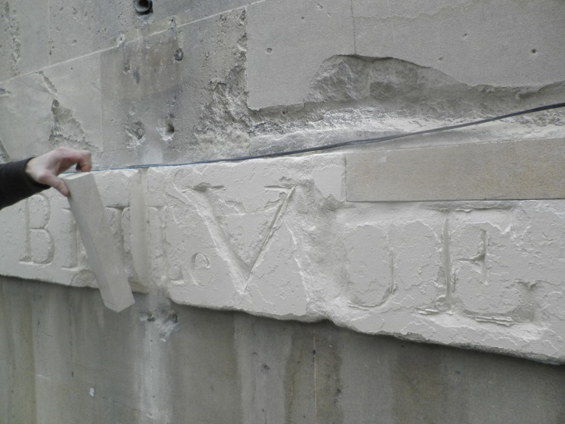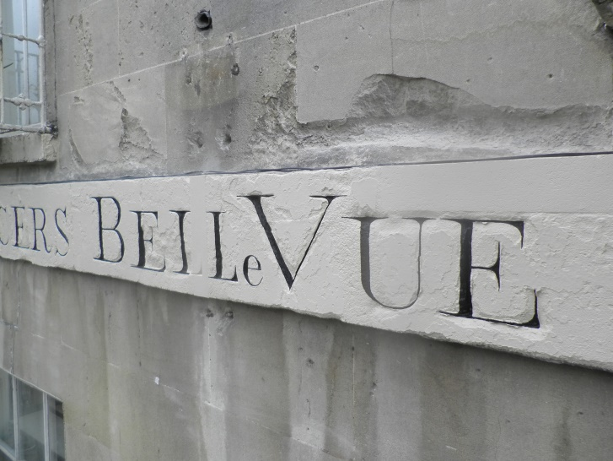
Before and after photographs of Spencers BelleVue street sign in Bath
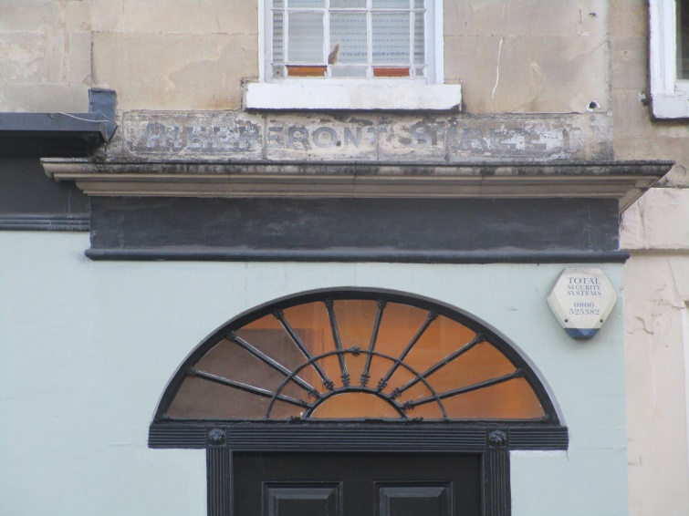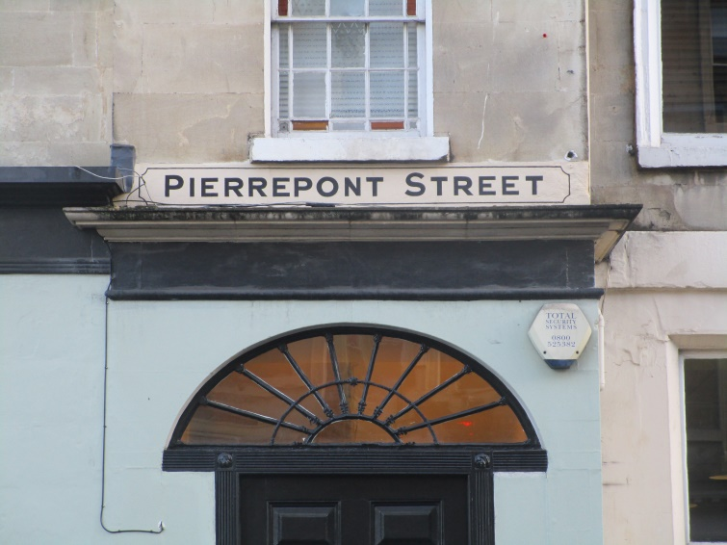
Before and after photographs of Pierrepont Street sign in Bath. This was the fiftieth sign to be restored in the 50th anniversary year (2018) of the Bath city-wide conservation area

-Ends-

For further information please contact: Janey Abbott, Communications Officer,
Bath Preservation Trust. Telephone: 01225 338727. Email: jabbott@bptrust.org.uk

Notes for Editors:
- The Bath Preservation Trust was set up in 1934 to safeguard the historic city of Bath. Bath is a UNESCO World Heritage Site, and the only complete city in the UK afforded World Heritage Status. The purposes of the Trust are: to encourage and support the conservation, evolution and enhancement of Bath and its environs within a framework appropriate both to its historic setting and its sustainable future, and to provide educational resources, including museums, which focus on the architectural and historic importance of the city. The Trust receives no statutory funding and is supported by visitor income, grants, legacies, donations and around 1400 members who share a passion for the city and its environs.
The Trust also runs four accredited museums in Bath and has the support of over 200 volunteers.

www.bath-preservation-trust.org.uk

- The Georgian Group is an English and Welsh conservation organisation created to campaign for the preservation of historic buildings and planned landscapes of the 18th and early 19th centuries. It was founded in 1937. It aims to save from destruction or disfigurement Georgian buildings, monuments, parks and gardens and encourage repair or restoration.

The Georgian Group’s Architectural Awards, sponsored by Savills, have been held annually for the last fifteen years and celebrate exemplary conservation and restoration projects in the UK. They provide an opportunity to recognise those who have shown vision and commitment in restoring Georgian buildings and landscapes. The 2019 awards ceremony took place on Tuesday 1 October at the Royal Institute of British Architects in London.
www.georgiangroup.org.uk

The Bath World Heritage Enhancement Fund is a partnership between the World Heritage Site Advisory Board, B&NES and BPT.
It has three aims:
- to initiate and organise minor enhancements to Bath's heritage;
- to assist and encourage others to undertake such work;
- to organise volunteers for the same purpose.

The Fund grew out of BPT’s Renovations Fund, which operated in the City at a smaller scale for 30+ years. It has organised or participated in over 30 projects across the World Heritage Site. These projects are almost always in partnership with other organisations, from community groups to national bodies such as the National Trust

www.bathworldheritage.org.uk/enhancement-fund

