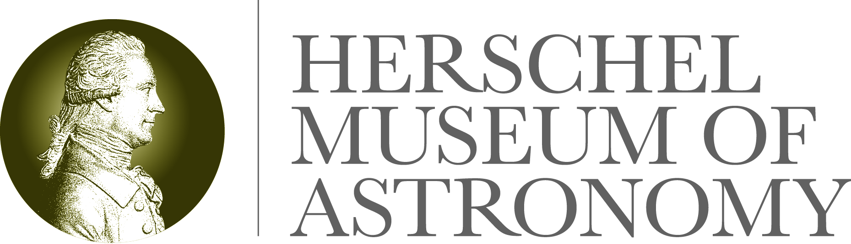
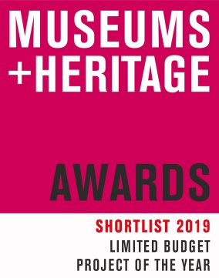

19 March 2019

The Herschel Museum of Astronomy’s small budget exhibition is rated one of the best in the country!

The Museums and Heritage Awards celebrate best practice within museums, galleries and heritage visitor attractions across the UK. In the category for projects with a limited budget achieving the biggest impact, our 2018 Wonder Women of Space exhibition has been shortlisted. Winners will be announced at a ceremony in London on 15 May.

Wonder Woman of Space was truly an exhibition run on a shoe-string, funded by a small Bath and North East Somerset Council Heritage Grant. We had big ideas and wanted to link with 2018 celebrations of Women’s Suffrage by focussing on female space heroines and showing how these role models inspire young people today and change the way we see the world. We also wanted to forge new partnerships with astronomical organisations both locally and worldwide.

The one-room exhibition was supported by a programme of family-focussed and space-themed craft activities plus talks from female scientists and several day and night-time stargazing opportunities (in partnership with Bath Astronomers Group). Public lectures were a sell-out and school visits took off – in part due to our successful partnership with Bath Astronomers. For the grand total of £980 and some clever use of social media, the popularity of Wonder Women of Space resulted in a 22% increase in visitor numbers over the year; a 68% rise in followers on Twitter (and 19% on Facebook); first visits from astronomers at Ohio State Univerisity, Royal Society London, Paris Astronomical Society and trustees of the University of Arizona; academic partnerships with ESA, NASA and the British Space Centre; features in national journals and several delightful star-gazing sessions with AgeUK B&NES.

Diane Lees, chair of the Museums and Heritage Awards judging panel and Director General of the Imperial War Museums said:

“It's been another year of amazing creativity despite the challenges of our sector. The shortlist features projects of great innovation and community focus making the job of judging very difficult.”
Claire Dixon, Director of Bath Preservation Trust Museums which includes the Herschel Museum of Astronomy, said:

“To use an appropriate metaphor we are over the moon at this recognition of our hard work and creative efforts. With a small team of mostly volunteers we have achieved incredible results and the legacy continues with an excellent start to 2019. I urge any of you to visit the Herschel Museum soon and discover for yourselves the magic of developments in space exploration and the contributions made by brother and sister William and Caroline Herschel.”

The Herschel Museum of Astronomy’s 2019 exhibition is open and is called Invisible Light: William Herschel and Infrared.

-Ends-

For further information please contact:

Janey Abbott, Communications Officer, Bath Preservation Trust

Telephone: 01225 338727 Email: jabbott@bptrust.org.uk

www.herschelmuseum.org.uk

Notes for editors
The Herschel Museum of Astronomy is dedicated to the many achievements of the Herschels, who were distinguished astronomers as well as talented musicians. It was from this house, using a telescope of his own design that William discovered the planet Uranus in 1781. His observations helped to double the known size of the solar system. Following a tradition of the great astronomers of the Renaissance he pushed forward the science of building telescopes. He was rewarded for his work by King George III, and also received the Copley Medal. Caroline also made a huge contribution to the field of astronomy. The work of the Herschels clearly had an impact on modern science and space exploration.
The late Sir Patrick Moore was a patron of the museum and described William Herschel as “the first man to give a reasonably correct picture of the shape of our star-system or galaxy, the best telescope-maker of his time, and possibly the greatest observer who ever lived”. Our current Patron is Dr Brian May.
Museums and Heritage Awards 2019

Shortlist for the Limited Budget Project of the Year
Wonder Women of Space Exhibition – Herschel Museum of Astronomy, Bath
“The Checks” Commemorating the Mining Communities of Kent – Studio Evans Lane as part of Historic England’s “Immortalised” exhibition
Chichester Roman Week 2018 – The Novium Museum
Happy Older People – National Museums Liverpool
Climate Hack – University of Cambridge Museums

