AN OPEN LETTER TO BATH RUGBY, THE REC TRUST, THE BATH CHRONICLE, B&NES COUNCIL and ENGLISH HERITAGE

18 November 2013

REC Consultation – BATH PRESERVATION TRUST’S INITIAL POSITION
Bath Preservation Trust has held back from speculating about future plans for the Rec until there was something ‘real’ to discuss. We believe that the current consultation represents this moment, and that there is an important public debate to be held before the plans are finalised.
While we reserve our final position for the planning application, The Trust’s current position (based on the limited information in the public domain) is as follows:
- We support the aim of improving facilities at the Rec for Bath Rugby and for all the spectators and visitors to Bath who come from all over the world to watch the team play.
- The proposed plans (a contemporary structure with a light touch achieved through using a textile roof) appear to offer a promising potential design solution to some of the site’s challenges, at the heart of a World Heritage city.
- We have always said that the landscape setting and the views into, out of and across the Rec are of crucial importance. The information now in the public domain does not address these key landscape considerations sufficiently or accurately with respect to views and heights. This suggests that proper analysis is only happening after the design concept has been revealed, rather than informing all elements of the design.
- We are particularly concerned about the height of the proposed West Stand at its highest point (from exhibition drawings about 1.5m higher than the tallest existing trees on the riverside, and taller than the existing floodlights). We are also concerned about the blocking effect that the East Stand, with its matching high roof, will have on through-views.
- We are not convinced that views to Prior Park from Johnstone Street, and to Sham Castle and Bathwick Hill from Grand Parade/Bog Island, will be maintained.
- We believe that the traditional ability to ‘peek’ into the ground from Johnstone Street and the Riverside, which has always given character to match days, will be lost.
- We are concerned that the roof should not be a monolithic block of colour, which would make it highly visible from the hills within and around Bath and potentially too intrusive into the setting. It should have texture and translucency.
- There is a need for B&NES to seize the opportunity to make significant improvements to the public realm and the access to the Rec, including the very unattractive access to/from Grove Street under Pulteney Bridge.
- It appears that the ground’s seating capacity, which is the main driver for the heights of the new stands, has not yet been fixed. We would like to see an alternative scheme presented which shows the lowest capacity acceptable to Bath Rugby, so that the public can make proper comparisons between the two, based on the impact on Bath’s precious views. We commend the practice in Switzerland where new developments are obliged to demonstrate by means of a physical scaffold frame the scale of their developments on-site, rather than depending on computer-generated impressions.
- Finally we believe it is the duty of the Local Planning Authority and the statutory consultees to achieve the best solution for both the landscape and townscape of our beautiful World Heritage City. We expect that further negotiations will be required in order to achieve the most positive outcome for all.
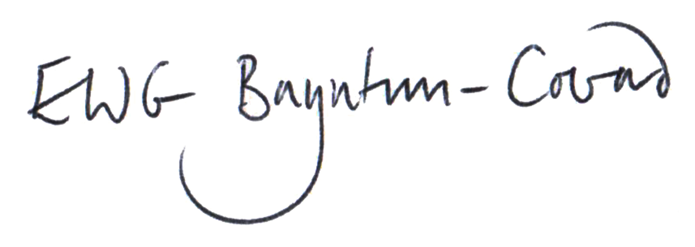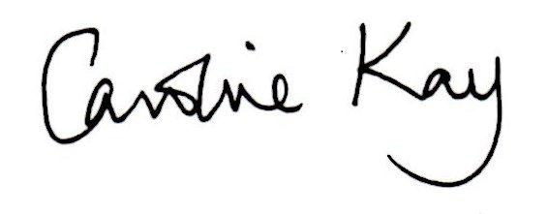
Edward Bayntun-Coward Caroline Kay
Chairman Chief Executive

